Our Ref: 975/2022

Contact: Greg Mottram

Ph: 02 XXXX XXXX

Date: XX May 2024

AUSTRAL HEIGHTS PTY LTD

Level 8 1 YORK ST

SYDNEY NSW 2000

**NOTICE OF DETERMINATION OF DEVELOPMENT APPLICATION**

***ENVIRONMENTAL PLANNING AND ASSESSMENT ACT 1979***

Pursuant to Section 4.16 of *the Environmental Planning and Assessment Act 1979*, Council has granted consent to your Development Application, described as follows:

|  |  |
| --- | --- |
| **APPLICANT:** | **THE TRUSTEE FOR THE AUSTRAL HEIGHTS DISCRETIONARY TRUST** |
| **LAND:** | **575 FIFTEENTH AVENUE AUSTRAL, LOT 384/-/DP2475**  **585 FIFTEENTH AVENUE AUSTRAL, LOT 385/-/DP2475**  **595-599 FIFTEENTH AVENUE AUSTRAL, LOT 8/-/ DP235953** |
| **PROPOSED DEVELOPMENT:** | **CONCEPT DEVELOPMENT APPLICATION FOR WAREHOUSES WITH ANCILLARY OFFICES, FOOD & DRINK PREMISES, SERVICE STATION, AND ASSOCIATED ACCESS, CAR PARKING, LANDSCAPING, FENCING, SIGNAGE, CIVIL WORKS INCLUDING STORMWATER MANAGEMENT, EARTHWORKS, DEMOLTION, TREE REMOVAL, DAM DE-WATERING, UTILITIES SERVICES CONNECTIONS, AND SUBDIVISION, TO BE DELIVERED IN STAGES.**  **THE APPLICATION INCLUDES DESIGN AND CONSTRUCTION OF THE FIRST STAGES OF DEVELOPMENT INVOLVING SUBDIVISION, CIVIL WORKS ACROSS THE WHOLE SITE, AND DESIGN AND CONSTRUCTION OF TWO WAREHOUSE BUILDINGS WITH ASSOCIATED VEHICLE ACCCESS, PARKING, LANDSCAPING, FENCING, SIGNAGE AND UTILITIES CONNECTIONS.** |
| **DETERMINATION:** | **APPROVAL SUBJECT TO CONDITIONS** |
| **CONSENT TO OPERATE FROM:** | **XX XXXXX 2024** |
| **CONSENT TO LAPSE ON:** | **XX XXXXX 2029** |

|  |  |
| --- | --- |
| **ATTACHMENTS:** | 1. **Conditions of Approval** 2. **Section 7.11 Payment Form** 3. **NSW RFS conditions** 4. **Sydney Water requirements** 5. **Endeavour Energy requirements** 6. **Transport for NSW requirements** |

Before commencing the development, please read the Development Consent carefully and make sure you understand all the conditions that have been imposed. Please contact Council if you have any questions.

**DEFINITIONS**

|  |  |
| --- | --- |
| AEP | Annual Exceedance Probability |
| Council | Liverpool City Council |
| DCP | Liverpool Growth Centre Precincts Development Control Plan 2021 |
| DECC | Department of Environment and Climate Change and Water |
| SWC | Subdivision Works Certificate |
| 1% AEP Flood | The 1 in 100 year flood |
| EP&A Act | *Environmental Planning and Assessment Act 1979* |
| EP&A Regulation | *Environmental Planning and Assessment Regulation 2021* |
| LRS | Land Registry Services |
| NCC | National Construction Code (formerly Building Code of Australia) |
| OC | Occupation Certificate |
| PCA | Principal Certifying Authority |
| POEO Act | *Protection of the Environment Operations Act 1997* |
| TfNSW | Transport for NSW |
| TBA | To Be Advised |

**CONDITIONS**

The following conditions have been imposed on the development to ensure all relevant planning requirements are met.

**ATTACHMENT 1 – CONDITIONS OF APPROVAL**

Council has imposed the following conditions under the relevant planning instruments and policies.

1. **THE DEVELOPMENT**

**Staging of Construction**

The conditions referenced in the below table apply to each stage of construction of the development as identified.

|  |  |  |  |
| --- | --- | --- | --- |
| **Stage** | **Development works** | **Part reference** | **Condition Reference** |
| **Stage 1** | * Provision of vehicle access off Fifteenth Avenue * Demolition of existing structures. * Dam-dewatering. * Removal of trees and vegetation. * Site remediation and bulk earthworks. * Internal access road and carparking area with associated services * Construction of a temporary detention basin at the north-western corner of the site. * Construction of two warehouses with 11 units with associated offices, signage and landscaping. * Subdivision to create 1 Torrens Title industrial lots and 4 residue lots for future road dedications. | All Parts | All conditions as relevant to the stage |
| **Stage 2** | * Construction of 9 food and drink premises and service station with associated vehicle access, car parking and landscaping. **Stage 2 is subject of future development assessment**. | All Parts | 1, 2, 7, 8, 11, 12,14, 15,16, & 17 and all that is relevant to the stage |
| **Stage 3** | * Stage 3 will commence after the precinct detention basin is constructed and operational. * Decommissioning of temporary stormwater management basin and temporary level spreader. * Construction of below ground tank with cartridge system to provide permanent on-site water quality treatment, and discharge to Council’s precinct stormwater system in the adjoining road reserve. * Relocation of driveway on north west corner, and re-landscaping of superseded driveway location. * Construction of the remaining 2 warehouse units with associated offices. | All Parts | All conditions as relevant to the stage |

**Approved Plans**

1. Development the subject of this determination notice must be carried out in accordance with the following approved plans/reports marked as follows, except where modified by the undermentioned conditions.
2. Architectural, Landscape and Subdivision Plans

|  |  |  |  |  |
| --- | --- | --- | --- | --- |
|  |  |  |  |  |
| **Plan Name** | **Drawing No.** | **Revision** | **Date** | **Prepared By** |
| Proposed Subdivision Plan | 1210063_ A007 | G | 22/04/2024 | Reid Campbell |
| Cover sheet / drawing list | A001 | G | 22/04/2024 | Reid Campbell |
| Site analysis | A002 | E | 23/08/2023 | Reid Campbell |
| Signage plan | A003 | E | 23/08/2023 | Reid Campbell |
| Perspectives | A004 | E | 23/08/2023 | Reid Campbell |
| Staging Diagram | A006 | C | 22/04/2024 | Reid Campbell |
| Draft subdivision plan | A007 | B | 23/08/2023 | Reid Campbell |
| Carpark allocation plan | A008 | A | 23/08/2023 | Reid Campbell |
| Demolition plan | A009 | A | 23/08/2023 | Reid Campbell |
| Concept plan - pre fifteenth avenue upgrade | A010 | A | 23/08/2023 | Reid Campbell |
| Concept plan - post fifteenth avenue upgrade | A011 | A | 23/08/2023 | Reid Campbell |
| Concept plan - post collector road upgrade | A012 | A | 23/08/2023 | Reid Campbell |
| Stage 1 of development site plan | A020 | H | 22/04/2024 | Reid Campbell |
| Stage 3 of development site plan | A021 | G | 23/08/2023 | Reid Campbell |
| Warehouse 1 plan | A101 | E | 23/08/2023 | Reid Campbell |
| Warehouse 1 roof plan | A102 | E | 23/08/2023 | Reid Campbell |
| Warehouse 2 plan | A103 | F | 23/08/2023 | Reid Campbell |
| Warehouse 2 roof plan | A104 | F | 23/08/2023 | Reid Campbell |
| Street elevations | A200 | E | 23/08/2023 | Reid Campbell |
| Warehouse 1 elevations n & e | A201 | F | 23/08/2023 | Reid Campbell |
| Warehouse 1 elevations s & w | A202 | F | 23/08/2023 | Reid Campbell |
| Warehouse 2 elevations n & e | A203 | F | 23/08/2023 | Reid Campbell |
| Warehouse 2 elevations s & w | A204 | F | 23/08/2023 | Reid Campbell |
| Warehouse 1 sections | A301 | F | 23/08/2023 | Reid Campbell |
| Warehouse 2 sections | A302 | F | 23/08/2023 | Reid Campbell |
| Office type 1 | A401 | E | 23/08/2023 | Reid Campbell |
| Office type 2 | A402 | F | 23/08/2023 | Reid Campbell |
| Office type 3 | A403 | E | 23/08/2023 | Reid Campbell |
| Office type 4 | A404 | F | 23/08/2023 | Reid Campbell |
| Office type 1 & 2 elevations | A411 | E | 23/08/2023 | Reid Campbell |
| Office type 3 & 4 elevations | A412 | E | 23/08/2023 | Reid Campbell |
| Office type 1 & 2 sections | A421 | E | 23/08/2023 | Reid Campbell |
| Office type 3 & 4 sections | A422 | E | 23/08/2023 | Reid Campbell |
| Landscape Cover Sheet | LDA-001 | D | 08/09/2023 | Ground Ink |
| Design intent & Material Palette | LDA-101 | D | 08/09/2023 | Ground Ink |
| Landscape Plan (Stage 1) | LDA-201 | D | 08/09/2023 | Ground Ink |
| Landscape Plan (Stage 2) | LDA-202 | D | 08/09/2023 | Ground Ink |
| Existing Tree Plan | LDA-203 | D | 08/09/2023 | Ground Ink |
| Proposed tree strategy | LDA-204 | D | 08/09/2023 | Ground Ink |
| Proposed understory Plant Strategy | LDA-205 | D | 08/09/2023 | Ground Ink |
| Landscape sections | LDA-296 | D | 08/09/2023 | Ground Ink |
| Detailed Landscape Plans 1&2 | LDA-207/208 | D | 08/09/2023 | Ground Ink |
| Planting Schedule | LDA-209 | D | 08/09/2023 | Ground Ink |
| Landscape Details | LDA-301 | D | 08/09/2023 | Ground Ink |
| Pedestrian Circulation Plans 1&2 | LDA-302 | D | 08/09/2023 | Ground Ink |

1. Civil Engineering Plans

|  |  |  |  |  |
| --- | --- | --- | --- | --- |
|  |  |  |  |  |
| **Plan Name** | **Drawing No.** | **Revision** | **Date** | **Prepared By** |
| General Arrangement Plan | C100 | C | 25/03/2024 | Infrastructure & development consulting |
| Notes and legends sheet | C105 | C | 08/12/2023 | Infrastructure & development consulting |
| Sediment and erosion control plan | C120 | C | 25/03/2024 | Infrastructure & development consulting |
| Demolition & Dam dewatering Plan | C125 | C | 08/12/2023 | Infrastructure & development consulting |
| Cut and Fill plan | C130 | C | 08/12/2023 | Infrastructure & development consulting |
| Site Sections Sheet 1 | C135 | C | 08/12/2023 | Infrastructure & development consulting |
| Site Sections Sheet 2 | C136 | C | 08/12/2023 | Infrastructure & development consulting |
| Road alignment control plan | C150 | C | 08/12/2023 | Infrastructure & development consulting |
| Road longitudinal sections | C160 | C | 25/03/2024 | Infrastructure & development consulting |
| Siteworks grading plan | C200 | C | 25/03/2024 | Infrastructure & development consulting |
| Stormwater management plan sheet 1 | C201 | C | 25/03/2024 | Infrastructure & development consulting |
| Pavement plan | C205 | C | 25/03/2024 | Infrastructure & development consulting |
| Siteworks details sheet 1 | C206 | C | 08/12/2023 | Infrastructure & development consulting |
| Siteworks details sheet 2 | C207 | C | 08/12/2023 | Infrastructure & development consulting |
| Siteworks details sheet 3 | C208 | C | 08/12/2023 | Infrastructure & development consulting |
| Siteworks details sheet 4 | C209 | B | 08/12/2023 | Infrastructure & development consulting |
| Siteworks details sheet 5 | C210 | A | 25/03/2024 | Infrastructure & development consulting |
| Temporary Stormwater Basin Plan | C215 | D | 25/03/2024 | Infrastructure & development consulting |
| Drains catchment plan | C220 | D | 24/08/2023 | Infrastructure & development consulting |
| External Catchment Plan | C225 | D | 24/08/2023 | Infrastructure & development consulting |
| Signage & Linemarking plan | C230 | D | 24/08/2023 | Infrastructure & development consulting |
| ILP overlay | C250 | D | 24/08/2023 | Infrastructure & development consulting |
| Siteworks and Stormwater Management Plan Phase 2A | C500 | C | 25/03/2024 | Infrastructure & development consulting |
| Siteworks and Stormwater Management Plan Phase 2B | C501 | A | 25/03/2024 | Infrastructure & development consulting |

1. Supporting Documentation

|  |  |  |  |
| --- | --- | --- | --- |
|  |  |  |  |
| **Report Name** | **Date** | **Reference** | **Prepared By** |
| Statement of Environmental Effects | 2/05/24 | 11648 | GLN Planning |
| Waste Management Plan | August 2022 | - | Waste audit |
| Acoustic Assessment | 16 August 2022 | 5541R001.NW.220816 | Acoustic Dynamics |
| Aboriginal Due Diligence Assessment Report | August 2022 | 3344 | OzArk |
| Bush Fire Assessment Report | 24 March 2022 | 220904 | Building Code & Bushfire  Hazard Solutions Pty Limited |
| Arborist Report | 18 March 2022 | E-001533-22 | Canopy Consulting |
| Odour Assessment | 16 August 2022 | - | Todoroski |
| Dam Dewatering Management Plan | 7 June 2022 | E25646.E16_Rev0 | EIAustralia |
| Geotechnical Investigation | 28 June 2022 | E25646.G03 | EIAustralia |
| Detailed Site Investigation and Soil Salinity Assessment | 7 June 2022 | E25646.E02.Rev0 | EIAustralia |
| Traffic Impact Assessment | April 2024 | 22.153r01v06 | Traffix |
| Internal Traffic Management Plan | September 2023 | 22.153r02v02 | Traffix |
| Stormwater Management and Infrastructure Report | 05 April 2024 | 21-034 | Infrastructure & Development Consulting |
| Economic Impact Assessment | July 2023 | - | Location IQ |
| Visual Impact Assessment | 14/08/2023 | - | Ground Ink |

**Environmental Planning and Assessment Act 1979**

1. In accordance with section 4.22(4) of the EP&A Act, development consent is granted for a Concept Development Application and the carrying out of the first stage of development as follows:
   1. Development consent is granted for a Concept Development Application for warehouses, food & drink premises, service station, and associated access, car parking, landscaping and fencing, signage, civil works including stormwater management, earthworks, demolition, dam de-watering, tree removal, utility services connections, and subdivision for part road dedications, to be developed in stages.
   2. Development consent is also granted for the design, construction and carrying out of the first stage of development involving subdivision, civil works across the whole site, and design and construction of two warehouse buildings with associated vehicle access, parking, landscaping, fencing, signage and utilities connections.
   3. A future stage Development Application is required for the design, construction and carrying out of the food and drink premises, the service station, and their associated vehicle access and car parking, landscaping and fencing, signage, and utilities connections.

**Pre-Development Application Meeting**

1. Prior to the submission of an application for the built form of food and drink premises and/or service station, a Pre-Development Application meeting is to be undertaken with Liverpool City Council. Advice of the subject Pre-Development application meeting is to be accompanied with the submission of the Development Application.

**EP&A Act Compliance**

1. The requirements and provisions of the EP&A Actand *Environmental Planning & Assessment Regulation 2021* must be fully complied with at all times. Failure to comply with these legislative requirements is an offence and may result in the commencement of legal proceedings, issuing of ‘on-the-spot’ penalty infringements or service of a notice and order by Council.

**External Agency General Terms of Approval and Requirements**

1. All requirements specified from external referral agencies, being (a) NSW Rural Fire Service, (b) Sydney Water, (c) Endeavour Energy and (d) Transport for NSW (as listed below), are to be adopted in the development. Referrals to external agencies are to take place for future development applications.
   1. **NSW Rural Fire Service (RFS)**

The development is to demonstrate compliance with all relevant conditions issued by the NSW Rural Fire Service, dated 28 February 2023(Attachment 3).

* 1. **Sydney Water Requirements**

The development is to demonstrate compliance with all relevant requirements issued by Sydney Water, issued 6 February 2024 (Attachment 4).

* 1. **Endeavour Energy Requirements**

The development is to demonstrate compliance with all relevant requirements issued by Endeavour Energy, issued 25 October 2023 (Attachment 5).

* 1. **Transport for NSW**

The development is to demonstrate compliance with all relevant requirements issued by Endeavour Energy, issued 29 January 2021 (Attachment 6).

**Works at no cost to Council**

1. All roadworks, drainage works and dedications, required to effect the consented development shall be undertaken at no cost to Liverpool City Council.

**Design Amendments – Warehouse Façade**

1. Prior to the issue of a construction certificate for Stage 1, revised plans, concluding landscape, architectural and civil plans, are to be submitted to Council to the satisfaction of the Manager of Development Assessment. The revised plans are to incorporate a minimum setback of 7m from the road reserve required by Transport NSW for the purpose of road widening of Fifteenth Avenue to enable the proposal to comply with the setback requirements in the Liverpool Growth Centres DCP.

**Special Conditions**

1. The gross floor area used for food and drink premises, including that attached to the service station, is not to exceed 2,105sqm.
2. The driveway off Fifteenth Avenue in both the interim and ultimate development stages is to be used only for left turn in and left turn out vehicle movements. It is not to be used for right turn in and right turn out vehicle movements at any stage.

1. Immediately following the construction and opening of the future public road along the eastern boundary of the site:
   1. the driveway off Fifteenth Avenue is to be modified and directional signage installed for the driveway to be used only for the purposes of access for the service station and its attached food and drink premises, and is not to be used for driveway access for any other use; and
   2. driveway access for the warehouse uses and the food and drink premises not attached to the service station is to be provided via driveways off the future public roads on the eastern boundary and/or northern boundary of the site.

If the service station and/or its attached food and drink premises are not operational during the time the future public road along the eastern boundary of the site is operational, then the driveway off Fifteenth Avenue is to be closed to all vehicle access until either of these uses is operational or under construction.

1. A revised internal traffic management plan is to be submitted that includes the traffic management measures to be implemented at the internal 4-way intersections of driveways, and the traffic management signage to be implemented across the site including at all intersections of driveways and surrounding roads.
2. A minimum of four existing large trees with a mature height of 10m or more are to be retained within the southern part of the site in the general location in or around the car parking areas for the food and drink premises and service station, and in a location that is within the site and not within the area identified for the future widening of Fifteenth Avenue. The trees to be retained must be identified in the approved Arborist Report as having high retention value.

Compliance with this condition may require a revision to the location of building footprints occupied by food & drink premises buildings and associated car parking in future stage Development Application/s for the design and construction of food & drink premises.

A revised landscape plan showing the trees being retained is to be submitted with the application for any construction certificate.

A report from a qualified arborist with recommended tree protection measures for the trees being retained during all civil works, earthworks and construction activity on the site are to be submitted with the application for any construction certificate.

Tree protection measures are to be implemented for the trees being retained on site for any and all civil works, earthworks and/or construction activity on the site in accordance with the tree protection plan.

1. A lighting plan describing the proposed lighting within the site is to be submitted for the approval of Council prior to the issue of a construction certificate for a building. The lighting plan needs to cover, at a minimum, the area which is the subject of the construction certificate.

The lighting plan must comply with relevant lighting standards and Council lighting policy for light spill in the public domain.

Lighting in the site must not cause unreasonable glare or nuisance on existing and future adjoining roads or in the adjacent residential zone to the south of the site.

1. A hazardous materials survey and asbestos management & remediation plan is to be prepared prior to a construction certificate for any civil works, earthworks or demolition, and implemented before commencement of any civil works, earthworks or demolition on the site.
2. A preliminary hazard analysis is to be submitted with a future stage Development Application for the design and construction of the service station in accordance with Chapter 3 of State Environmental Planning Policy (Resilience and Hazards) 2021.
3. A crime prevention through environmental design report is to be submitted with any future stage Development Application for the design and construction of the food & drink premises and/or service station.
4. A Site Operational Management Plan is to be submitted for Council approval and to the certifier at the times specified below. The management plan is to describe measures for managing the site and ongoing operation of the approved development including, but not necessarily limited to, management responsibilities of the site owner/manager and tenants/ occupants, site safety and security, internal vehicle and pedestrian traffic, car parking, noise, efficient energy use, efficient water use, cleaning and maintenance, waste management, vermin and pest control, maintenance of landscape vegetation, maintenance of stormwater management system, maintenance for bushfire protection, handling of complaints and incidents, ongoing training and updating of tenants/occupants in the management plan.

The Site Operational Management Plan is to be consistent with all the terms and conditions specified in this development consent.

The Site Operational Management Plan (SOMP) is to be submitted at the following times:

1. A SOMP for the first stage warehouse part of the development is to be submitted for Council approval and to the certifier prior to the occupation certificate for that first stage.
2. A SOMP for the second stage food & drink premises and service station part of the development is to be submitted with the future stage Development Application.

**Council Waste-Water Requirements**

1. The development must provide for a physical sewerage connection to each use to enable the method of sewage disposal by gravity reticulation mains to either, Sydney Water branch and trunk sewers or Sydney Water point of treatment. Liverpool City Council will not accept any temporary facilities to service the site, including pump-out sewage systems.

**Stage** **3**

1. Stage 3 can occur with written consent from Council at any time after the completion of Stage 1 and only occurring once temporary stormwater treatment facilities are no longer required for the site subject to the development of the regional drainage network and a separate Construction Certificate has been issued.

**B.** **PRIOR TO ISSUE OF A CONSTRUCTION CERTIFICATE**

**The following conditions are to be complied with or addressed prior to the issue of a Construction Certificate by the Principal Certifying Authority.**

**Site Development Work**

1. Site development work in the form of excavation, underpinning or shoring works must not take place, until such time as a Construction Certificate has been issued.

**Special Infrastructure Contribution**

1. The applicant is to make a special infrastructure contribution in accordance with any determination made by the Minister administering the Environmental Planning and Assessment Act 1979 under Section 7.23 of that Act and is in force on the date of this consent, and must obtain a certificate to that effect from the Department of Planning (Growth Centres Commission) before a construction certificate is issued in relation to any part of the development to which this consent relates.

**Section 7.11 PAYMENT - Liverpool Contributions Plan 2021 Austral Leppington North Precinct – Stage 1 and Stage 3**

1. As a consequence of this development, Council has identified an increased demand for public amenities and public services. The following payment is imposed in accordance with above Liverpool Contributions Plan 2021 Austral & Leppington North as amended.

The total contribution **(Excluding Stage 2 which will be imposed as part of a future development application)** is $**2,477,776** and will be adjusted at the time of payment in accordance with the contributions plan.

Stage 1 **$2,254,450**

Stage 2 Subject to future development application.

Stage 3 **$ 223,326**

A breakdown of the contributions payable is provided in the attached payment form.

The Contributions Plan may be inspected online at [www.liverpool.nsw.gov.au](http://www.liverpool.nsw.gov.au/). Payment must be accompanied by the attached form.

**Bonds**

1. A maintenance bond in the form of a bank Guarantee or cash bond ($TBA), shall be lodged with Council prior to the issue of a Construction Certificate. The bond shall cover maintenance and any damage to roads, drainage lines, public reserves or other council property or works required as a result of work not in accordance with Council’s standards, and /or development consent conditions. The bond will be held by Council for a minimum period of 6 months from the date of Council acceptance of final works.

**Maintenance Bond**

1. Prior to the issue of a Construction Certificate a maintenance bond is to be lodged with Liverpool City Council for road and drainage works.

The value of the bond shall be determined in accordance with Liverpool City Council’s Bond Policy.  The bond will be administered in accordance with this policy.

**Fee Payments**

1. Unless otherwise prescribed by this consent, all relevant fees or charges must be paid. Where Council does not collect these payments, copies of receipts must be provided. For the calculation of payments such as Long Service Levy, the payment must be based on the value specified with the Development Application.

The following fees are applicable and payable:

1. Damage Inspection Fee – relevant where the cost of building work is $20,000 or more, or a swimming pool is to be excavated by machinery.
2. Fee associated with Application for Permit to Carry Out Work Within a Road, Park and Drainage Reserve.

These fees are reviewed annually and will be calculated accordingly.

**Long Service Levy**

1. Before the issue of a construction certificate, the long service levy of 0.25% of the cost of building and construction works of $250,000 and or more (including GST) as calculated at the date of this consent, must be paid to the Long Service Corporation of Council under the Building and Construction industry Long Service Payments Act 1986, section 34, and evidence of the payment is to be provided to the Principal Certifier.

**Notification**

1. The Principal Certifying Authority must advise Council, in writing of:

(a) The name and contractor licence number of the licensee who has contracted to do or intends to do the work, or

(b) The name and permit of the owner-builder who intends to do the work.

If these arrangements are changed, or if a contact is entered into for the work to be done by a different licensee, Council must be immediately informed.

**S138 Roads Act – Minor Works in the public road**

1. Prior to the issue of a Construction Certificate, a Section 138 Roads Act application/s, including payment of fees shall be lodged with Liverpool City Council, as the Roads Authority for any works required in a public road. These works may include but are not limited to the following:
2. Vehicular crossings (including kerb reinstatement of redundant vehicular crossings)
3. Road opening for utilities and stormwater (including stormwater connection to Council infrastructure)
4. Road occupancy or road closures

All works shall be carried out in accordance with the *Roads Act* approval, the development consent including the stamped approved plans, and Liverpool City Council’s specifications.

Note: Approvals may also be required from the Roads and Maritime Service (RMS) for classified roads.

**Access, Car Parking and Manoeuvring – General**

1. Prior to the issue of a Construction Certificate the Certifying Authority shall ensure and certify that vehicle access, circulation, manoeuvring, pedestrian and parking areas associated with the subject development have been designed and are in accordance with AS2890.1, AS290.2, AS2890.6 and Council’s Development Control Plan.

**Access, Car Parking and Manoeuvring – Detail**

1. The Certifying Authority shall ensure and certify that:
2. Off street access and parking complies with AS2890.1,
3. Vehicular access and internal manoeuvring have been designed for the longest (B-Double/ Heavy Rigid/ Medium Rigid) vehicle expected to service the development site, in accordance with AS2890.2,
4. Sight distance at the street frontage has been provided in accordance with AS 2890.1,
5. All vehicles can enter and exit the site in a forward direction, and/or
6. Requirements of the Disability Discrimination Act 2002, Disability Standards for Accessible Public Transport and the Guidelines for assessing compliance of bus stops with the Disability Standards for Accessible Public Transport 2002,

**Road Works**

1. Works within the public road reserve shall not commence until the design drawings including the associated signs and line marking scheme have been approved by Council’s Traffic Management Section.

**Street Lighting**

1. The design of street lighting in accordance with Council’s and Endeavour Energy specifications along all the roads fronting the development site should be submitted to Council Transport Management Section for review.

**Public Domain Works – Street Lighting**

1. The approved street lighting designs are to be implemented along all new and existing streets within the proposed development in accordance with Liverpool City Council standards and to the satisfaction of Council.

All street lighting must comply with the service provider Street Lighting Policy and illumination requirements and Council’s Street Lighting policy.

All cost associated with the installation of street lighting shall be borne by the developer.

**Bus Stops**

1. Possible Bus Stop locations are to be discussed with the local bus companies and are to be designed in accordance with bus company requirements including incorporating the requirements of the Disability Discrimination Act 2002, Disability Standards for Accessible Public Transport and the Guidelines for assessing compliance of bus stops with the Disability Standards for Accessible Public Transport 2002.

**Road Safety Audit**

1. A Stage 3 (detailed design) Road Safety Audit (RSA) shall be undertaken on the proposed roadworks by an accredited auditor who is independent of the design consultant. A copy of the RSA shall accompany the design plans submitted with the Construction Certificate or Roads Act application.

Prior to the issue of the Construction Certificate or Roads Act approval, the Certifying Authority shall ensure that the recommendations of the RSA have been addressed in the final design.

**Detailed Design Drawings**

1. The applicant is to discuss with Council’s Traffic Management Section of the traffic requirements prior to undertaking the detailed design of traffic facilities, signs and linemarking in the existing and/or proposed public domain.

The plans should include, but not be limited to:

* + - 1. Driveway access off Fifteenth Avenue is to be restricted to left in / left out both in the temporary and ultimate scenario. It will service the whole site temporarily until the Collector Road on the eastern boundary of the site is fully constructed.
      2. The driveway off Fifteenth Avenue is to be designed as per the design that was endorsed by TfNSW and minimise disruption to through traffic on Fifteenth Avenue when vehicles enter and exit the site.
      3. Following the construction of the Collector Road access will be provided from this road to all other developments on the site. They will not have access off Fifteenth Avenue
      4. Traffic management measure of physical nature is to be provided to ensure that the driveway off Fifteenth Avenue serves only the service station.

Detailed design drawings of the proposed traffic facilities, signs and line markings in the existing and proposed public domain areas are to be submitted to Council for approval using Approval of Traffic Facilities including Signs and Line Marking Schemes Application Form. The application is available on Council website and should be lodged online. The drawings are to be prepared by a suitably qualified person.

**No Loading on Easements**

1. Prior to the issue of a Construction Certificate the Certifying Authority shall ensure that the foundations of proposed structures adjoining the drainage and/ or services easement have been designed clear of the zone of influence.

**Retaining Walls on Boundary**

1. All retaining walls, if proposed, shall be of masonry construction and must be wholly within the property boundaries, including footings and agricultural drainage lines. Construction of retaining walls or associated drainage works along common boundaries shall not compromise the structural integrity of any existing structures.

Where a retaining wall exceeds 600mm in height, the wall shall be designed by a practicing structural engineer and a Construction Certificate must be obtained prior to commencement of works on the retaining wall.

**Water Quality**

1. Prior to the issue of a Construction Certificate the Certifying Authority shall ensure that details of a stormwater pre-treatment system have been provided on the stormwater plans and that the design meets pollutant retention criteria in accordance Council’s Development Control Plan.

The Construction Certificate must be supported by:

* Specification & installation details of the stormwater pre-treatment system
* The approval of an operation and maintenance manual/schedule for the stormwater pre-treatment system

A copy of the approved operation and maintenance manual/schedule shall be submitted to Liverpool City Council with notification of the Construction Certificate issue.

**Construction Environmental Management Plan (CEMP)**

1. Prior to issue of a Construction Certificate, a Construction Environmental Management Plan (CEMP) for the development must be provided to the Principal Certifying Authority for approval. The environmental site management measures must remain in place and be maintained throughout the period of the development. The CEMP must address all environmental aspects of the development’s construction phases and include, but not be limited to, the following:
2. Asbestos Management Plan;
3. Project Contact Information;
4. Site Security Details;
5. Timing and Sequencing Information;
6. Site Soil and Water Management Plan;
7. Noise and Vibration Control Plan;
8. Dust Control Plan;
9. Air Monitoring;
10. Odour Control Plan;
11. Health and Safety Plan;
12. Waste Management Plan;
13. Incident management Contingency; and
14. Unexpected Finds Protocol.

The CEMP must be kept on site for the duration of the works and must be made available to Council Officers upon request.

**Telecom Pits**

1. Prior to the issue of a Construction Certificate written acceptance is to be obtained from the relevant authority for the location of the proposed works (e.g. new road connection to Fourth Avenue) adjoining/impacting the existing asset (e.g. Telecom pit, power pole) within the public road, and/or any alternative requirements by the relevant Authority, and is to be provided to the Principal Certifier. A copy of the written acceptance and/or their alternative requirements is also to be provided to Council. For Telecom pits acceptance from Telstra Network Integrity (1800 810 443) is required and for NBN contact 1800 687 626.

**Asbestos management**

1. Provisions regarding the removal, handling, wrapping and disposal of asbestos construction materials as well as the destination of disposal will be required as per conditions from NSWEPA and NSW Workcover.

**S138 Roads Act - roadworks requiring approval of civil drawings**

1. Prior to the issue of a Construction Certificate for building or subdivision works the Certifying Authority shall ensure that a S138 Roads Act application, including the payment of application and inspection fees, has been lodged with Liverpool City Council (being the Roads Authority under the Roads Act), for provision of drainage works in Gurner Avenue.  
     
   Engineering plans are to be prepared in accordance with the development consent, Liverpool City Council’s Design Guidelines and Construction Specification for Civil Works, Austroad Guidelines and best engineering practice.

Note: Where Liverpool City Council is the Certifying Authority for the development the Roads Act approval for the above works may be issued concurrently with the Construction

**Road design criteria table**

1. Prior to the issue of a Construction Certificate the Certifying Authority shall ensure that the proposed roads have been designed in accordance with Liverpool City Council’s Design Guidelines and Construction Specification for Civil Works and the following criteria:

|  |  |  |  |  |  |
| --- | --- | --- | --- | --- | --- |
| Road No. | Road Reserve Width | Carriageway Width | Verge | Footpath (1.5m wide) | ESA |
| Walnut Ave | 10.00m ( Half Road) | 5.5m(half road) | 4.5m | South side | 3x10^5 |

#### On-Site Detention

1. On-Site Detention shall be provided generally in accordance with the concept plan/s lodged for development approval, prepared by IDC, reference number 21-034-DA-C, revision E, dated 25/03/2024.

The proposed development and stormwater drainage system shall be designed to ensure that stormwater runoff from upstream properties is conveyed through the site without adverse impact on the development or adjoining properties.

Engineering plans and supporting calculations for the on-site detention system are to be prepared by a suitably qualified person and shall accompany the application for a Construction Certificate.

Prior to the issue of a Construction Certificate the Certifying Authority shall ensure that the on-site detention system has been designed in accordance with Liverpool City Council’s Design Guidelines and Liverpool City Council’s On-Site Stormwater Detention policy and Technical Specification.

**Water Quality**

1. Prior to the issue of a Construction Certificate, the Certifying Authority shall ensure that details of a stormwater pre-treatment system have been provided on the stormwater plans and that the design meets pollutant retention criteria in accordance Council’s Development Control Plan.

The Construction Certificate must be supported by:

* 1. Specification & installation details of the stormwater pre-treatment system
  2. The approval of an operation and maintenance manual/ schedule for the stormwater pre-treatment system

A copy of the approved operation and maintenance manual/ schedule shall be submitted to Liverpool City Council with notification of the Construction Certificate issue.

**Flooding**

1. Existing overland flows running through the site shall be captured and managed, and the proposed development shall not have any adverse flooding impact in the vicinity as indicated in the overland flood impact assessment report by Infrastructure & Development Consulting (IDC) Pty Ltd (Ref: Project Number: 21-034, Stormwater Management & Infrastructure Report: Fyve Austral – 575-595 Fifteenth Avenue Austral, Revision: D; dated: 05 April 2024).
2. Stormwater drainage system of the proposed development shall consider future developments in upstream properties. The design of the stormwater pipe system within the development shall ensure it has sufficient capacity to accommodate increased post-development flows from upstream sources.
3. During the 1% AEP storm event, the depth of flooding and velocity*depth on the road shall not be higher than 0.2m and 0.4 m2/s, respectively.
4. Stormwater flows generated from the proposed development site shall be attenuated by interim on-site detention (OSD) basin as detailed in the stormwater management report (Ref: Project Number: 21-034, Stormwater Management & Infrastructure Report: Fyve Austral – 575-595 Fifteenth Avenue Austral, Revision: D; dated: 05 April 2024), and accompanying design plans (Ref: Drawing No. 21-034-DA-C201, Revision: E, dated: 25/03/2024; and Drawing No. 21-034-DA-C215, Revision: D, dated: 25/03/2024) by Infrastructure & Development Consulting (IDC) Pty. The basin shall be designed to ensure that peak post-development discharges from the site do not exceed peak pre-development discharges for the 20%, 5%, and 1% AEP storm events. The design shall also demonstrate that the site discharge will drain by gravity to the nominated point of discharge. The interim OSD basin shall be maintained at the site until Basin 18 is constructed and the stormwater network up to the creek is established. The basin cannot be removed without Council's written consent.
5. For the interim stormwater management prior to the completion of Basin 18 and the associated drainage infrastructure, a temporary level spreader shall be provided at the north-west corner of the site as indicated in the stormwater management report (Ref: Project Number: 21-034, Stormwater Management & Infrastructure Report: Fyve Austral – 575-595 Fifteenth Avenue Austral, Revision: D; dated: 05 April 2024), and accompanying design plan (Ref: Drawing No. 21-034-DA-C210, Revision: A, dated: 25/03/2024) by Infrastructure & Development Consulting (IDC) Pty. The level spreader shall ensure that the existing flow regime is maintained and the stormwater outflow from the interim on-site detention (OSD) basin are discharged as sheet flow to the downstream overland flow path. The level spreader shall be maintained at the site until Basin 18 and the associated drainage infrastructure are completed.
6. Interim on-site water quality treatment facilities shall be provided to ensure that stormwater runoff leaving the site complies with Council's water quality standards, as outlined in the stormwater management report (Ref: Project Number: 21-034, Stormwater Management & Infrastructure Report: Fyve Austral – 575-595 Fifteenth Avenue Austral, Revision: D; dated: 05 April 2024), and accompanying design plans (Ref: Drawing No. 21-034-DA-C201, Revision: E, dated: 25/03/2024; and Drawing No. 21-034-DA-C215, Revision: D, dated: 25/03/2024) by Infrastructure & Development Consulting (IDC) Pty Ltd. The water quality treatment works shall be designed using MUSIC modelling software, and the performance of the water quality treatment system shall be verified using Council's MUSIC link. Interim water quality basins shall be maintained at site until Basin 18 is constructed and streetscape raingardens are constructed in accordance with Council's masterplan.
7. Interim silt trap at the location of streetscape raingarden shall be included at the road intersection near the northeast corner of proposed Warehouse 2 as indicated in Liverpool growth centre DCP 2021. The design of silt trap shall be in accordance with interim silt trap device construction details provided in Liverpool Growth Centre Precinct DCP, 18 June 2021 and/or detailed design of streetscape raingarden presented in Development of Streetscape Raingarden Masterplan for Austral and Leppington North.
8. Following the completion of Basin 18 and its drainage infrastructure, the temporary level spreader is to be decommissioned and the upstream drainage infrastructure shall be connected to the downstream trunk drainage system of Basin 18 as indicated in the stormwater management report (Ref: Project Number: 21-034, Stormwater Management & Infrastructure Report: Fyve Austral – 575-595 Fifteenth Avenue Austral, Revision: D; dated: 05 April 2024), and accompanying design plan (Ref: Drawing No. 21-034-DA-C501, Revision: A, dated: 25/03/2024) by Infrastructure & Development Consulting (IDC) Pty.
9. Permanent on-site water quality treatment facilities shall be provided after the decommissioning of the interim onsite basin. The design of these facilities shall consider all potential future commercial or industrial uses of the site, ensuring that stormwater runoff leaving the premises meets the water quality standards set by Council. Water quality treatment works shall be designed using MUSIC modelling software and the water quality treatment system performance shall be verified using Council’s MUSIC link. Water quality modelling report along with electronic copies of the MUSIC model, shall be submitted to Council for review and approval.
10. Wastewater, petroleum, and other hazardous chemicals originating from future service stations, food/drink establishments, and car wash facilities must not be released into waterways or the Council's stormwater system. An efficient system shall be established to contain any oil spills and safely dispose of them at approved locations. Furthermore, adequate pollution control measures must be established to capture, treat, and safely dispose of hazardous pollutants from the site.

**Crime Prevention through Environmental Design**

1. It is recommended that the following Crime Prevention through Environmental Design (CPTED) principles be incorporated into the building. Where necessary, plans shall be amended to reflect incorporation of the principles and/or details of such to be submitted to the PCA:
2. Back to base alarm systems shall be considered;
3. Basement parking areas shall be painted a light colour;
4. CCTV for the ground level, entry/exit points, car parks, lifts and the exterior of the building shall be considered;
5. ‘Way finding’ signage should be utilised at all major interchanges such as lifts and stair wells;
6. Lighting is required to be designed in accordance with the Australian and New Zealand Lighting Standard AS 1158. A lighting maintenance policy should be established. Security lighting should be installed in and around the building, and such shall not impact on any adjoining premises. The lighting should be vandal resistant, especially external lighting;
7. Corrugated ramps should be considered to prevent skate boarding activities;
8. Glazed tiling, patterned, porous and non solid surfaces reduce the reward for graffiti offenders;
9. Any external approved palisade or pool style fencing shall be black in colour, unless otherwise noted on the approved plans/details;

**Access, Car Parking and Manoeuvring – General**

1. Prior to the issue of a Construction Certificate the Certifying Authority shall ensure that vehicular access, circulation, manoeuvring, pedestrian and parking areas associated with the subject development are in accordance with AS 2890.1, AS2890.2, AS2890.6 and Liverpool City Council’s Development Control Plan.

**Driveway Design**

1. All proposed driveways are to be designed and constructed to Council’s Industrial Driveway Standard.

**Glazing**

1. Glazing shall not exceed a reflectivity of 20%.

**C. PRIOR TO WORKS COMMENCING**

**The following conditions are to be complied with or addressed prior to works commencing on the subject site/s:**

**Commencement of work**

1. Building work shall not commence prior to the issue of a Construction Certificate. Building work as defined under Section 1.4 of the EP&A Act means any physical activity involved in the erection of a building and includes but is not limited to, the placement of any site shed/s or builders facilities, site grading, retaining walls, excavation, cutting trenches, installing formwork and steel reinforcement or, placing of plumbing lines.
2. Construction Certificate must be obtained from the Council or an accredited certifier, in accordance with the provisions of the *Environmental Planning & Assessment Act 1979.*
3. Where a Construction Certificate is obtained from an Accredited Certifier, the applicant shall advise Council of the name, address and contact number of the Accredited Certifier, in accordance with Section 81A (4) of the Act.
4. A copy of the Construction Certificate, the approved development consent plans and consent conditions must be kept on the site at all times and be made available to the Council officers and all building contractors for assessment.
5. A Principal Certifying Authority (PCA) must be appointed to carry out the necessary building inspections and to issue an occupation certificate; and
6. The PCA must advise Council of the intended date to commence work which is the subject of this consent by completing a notice of commencement of building works or subdivision works form, available from Council’s Customer Service Centre. A minimum period of two (2) working days’ notice must be given.
7. Detailed engineering plans and specifications relating to the work shall be endorsed with a CC, in accordance with Section 81A of the EP&A Act, and a copy submitted to Council, with payment of any relevant fees.
8. Any CC that may be issued in association with this development consent must ensure that any certified plans and designs are generally consistent (in terms of site layout, site levels, building location, size, external configuration and appearance) with the approved Development Application plans.
9. Detailed engineering plans and specifications relating to the work shall be endorsed with a CC, in accordance with Section 4.19, 6.6, 6.7, 6.12, 6.13, 6.14 of the EP&A Act, and a copy submitted to Council, with payment of any relevant fees.
10. Any CC that may be issued in association with this development consent must ensure that any certified plans and designs are generally consistent (in terms of site layout, site levels, building location, size, external configuration and appearance) with the approved Development Application plans.
11. Where this consent requires both engineering and building works to be undertaken, a separate Construction Certificate shall be issued for each category of works i.e., a separate Civil Engineering CC and a separate Building CC.

**Notification**

1. Notification to surrounding residents is to be undertaken within a 100-meter radius from the site. A letter box drops in the form of an informative pamphlet or the like is to be carried out at least 5 days prior to the event to local residents informing them of the event details and including contact details of the site supervisor for the event.

**Construction Traffic Management Plan**

1. A construction traffic management plan (CTMP) prepared by a suitably qualified person is to be submitted to and endorsed by Council’s Transport Management Section. The CTMP is to be submitted using Assessment of Construction Traffic Management Plan application form. The application is available on Council website and can be lodged online. Comments on the CTMP will be provided and the updated CTMP are to be implemented during construction.

A copy of the endorsed CTMP and traffic control plans are to be available on the works site for inspection by authorised Council officers.

Construction shall not commence until the assessed construction traffic management plan has been endorsed. The endorsed CTMP is to be implemented during construction.

**Road Occupancy Permit**

1. Road occupancy and road opening approvals will be required from Council to undertake works within the existing road reserve. The following applications are available on Council’s website and can be lodged online attaching all required documents indicated on the application form.

• Road Occupancy Application Form

• Road Opening Application Form

**Demolition Works**

1. Demolition works shall be carried out in accordance with the following:
2. Prior to the commencement of any works on the land, a detailed demolition work plan designed in accordance with the Australian Standard AS 2601-2001 – The Demolition of Structures, prepared by a suitably qualified person with suitable expertise or experience, shall be submitted to and approved by Council and shall include the identification of any hazardous materials, method of demolition, precautions to be employed to minimise any dust nuisance and the disposal methods for hazardous materials,
3. Prior to commencement of any works on the land, the demolition Contractor(s) license details must be provided to Council, and
4. The handling or removal of any asbestos product from the building/site must be carried out by a SafeWork NSW licensed contractor irrespective of the size or nature of the works. Under no circumstances shall any asbestos on site be handled or removed by a non-licensed person. The licensed contractor shall carry out all works in accordance with SafeWork NSW requirements.

**Notice of Commencement for Demolition**

1. At least one week before demolition work commences, written notice must be provided to council and the occupiers of neighbouring premises of the work commencing. The notice must include:
2. name
3. address,
4. contact telephone number,
5. licence type and license number of any demolition waste removal contractor and, if applicable, asbestos removal contractor, and
6. the contact telephone number of council and
7. the contact telephone number of SafeWork NSW (4921 2900).

**Work Zone**

1. A Works Zone application is required if on-street parking is affected with commuter parking and there is insufficient off-street parking space.

A Works Zone Application Form is available on Council website and can be lodged online by attaching all required documents indicated on the application form.

**Environmental Management**

1. Adequate soil and sediment control measures shall be installed and maintained. Furthermore, suitable site practices shall be adopted to ensure that only clean and unpolluted waters are permitted to enter Council’s stormwater drainage system during construction/demolition. Measures must include, as a minimum:
   1. Siltation fencing;
   2. Protection of the public stormwater system; and
   3. Site entry construction to prevent vehicles that enter and leave the site from tracking loose material onto the adjoining public place.

**Dilapidation Report**

1. Before any site work commences, a dilapidation report must be prepared by a suitably qualified engineer detailing the structural condition of adjoining buildings, structures or works and public land, to the satisfaction of the Principal Certifier.

Where access has not been granted to any adjoining properties to prepare the dilapidation report, the report must be based on a survey of what can be observed externally and demonstrate, in writing, to the satisfaction of the Principal Certifier, that all reasonable steps were taken to obtain access to the adjoining properties.

**Site Notice Board**

1. A sign must be erected in a prominent position on the premises on which work is to be carried out. The sign is to be maintained during work, and removed at the completion of work. The sign must state:
2. The name, address and telephone number of the principal certifying authority for the work; and
3. The name of the principal contractor (if any) for any building work and a telephone number on which that person may be contacted outside working hours; and
4. Unauthorised entry to the premises is prohibited.

**Matters to be addressed prior to commencement of works**

1. Works shall not commence until:
2. a Construction Certificate (if required) has been issued,
3. a Principal Certifying Authority has been appointed for the project, and
4. any other matters prescribed in the development consent for the subdivision and the EP&A Act and *Environmental Planning and Assessment Regulation 2021* have been complied with.

A Notice of Commencement is to be submitted to Liverpool City Council two (2) days prior to commencement of engineering works or clearing associated with the subdivision.

**Site Facilities**

1. Adequate refuse disposal methods and builders storage facilities shall be installed on the site. Builders’ wastes, materials or sheds are not to be placed on any property other then that which this approval relates to.

**Demolition and removal**

1. Prior to any works commencing, any air-conditioning or refrigeration systems fitted to the dwelling or outbuildings to be demolished, must have the refrigerants present in those systems extracted into a durable, air-tight container by a licensed air-conditioning technician. This container and its contents must be sent intact, for secure destruction, to a facility licensed to destroy such refrigerants. Documentary evidence that this has been completed, if indeed these systems are fitted to the dwelling, must be sighted by the Principal Certifying Authority and included as part of the Occupation Certificate documentation.

**Erosion and sediment control plan**

1. Before site work commences, an erosion and sediment control plan must be prepared by a suitably qualified person in accordance with the following documents and provided to the Principal Certifying Authority:
2. Council’s relevant development control plan,
3. the guidelines set out in the NSW Department of Housing manual ‘Managing Urban Stormwater: Soils and Construction Certificate’ (the Blue Book) (as amended from time to time), and
4. the ‘Do it Right On-Site, Soil and Water Management for the Construction Industry' (Southern Sydney Regional Organisation of Councils and the Natural Heritage Trust) (as amended from time to time).

**Erosion and sediment controls in place**

1. Before any site work commences, Council must be satisfied the erosion and sediment controls in the erosion and sediment control plan are in place. These controls must remain in place until any bare earth has been restabilised in accordance with the NSW Department of Housing manual ‘Managing Urban Stormwater: Soils and Construction Certificate’ (the Blue Book) (as amended from time to time).

**Waste Management Plan requirements**

1. Before site work commences, a waste management plan for the development must be prepared and provided to the Principal Certifying Authority. The plan must:
2. be prepared in accordance with -
   * 1. the Environment Protection Authority’s Waste Classification Guidelines as in force from time to time, and
     2. a development control plan that provides for waste management that applies to the land on which the work or the clearing of vegetation is carried out, and
3. include the following information—

the contact details of the person removing waste,

* + 1. an estimate of the type and quantity of waste,
    2. whether waste is expected to be reused, recycled or sent to landfill,
    3. the address of the disposal location for waste.

A copy of the waste management plan must be kept on-site at all times while work approved under the development consent is being carried out.

**Asbestos Removal Control Plan**

1. Before site work commences, an Asbestos Removal Control Plan and Work Health and Safety Plan for the development must be prepared and provided to the Principal Certifying Authority in accordance with the recommendations of the approved Remediation Action Plan.

**Site preparation**

1. Before demolition work commences the following requirements must be in place until the demolition work and demolition waste removal are complete:
2. Protective fencing and any hoardings to the perimeter on the site
3. Access to and from the site
4. Construction traffic management measures
5. Protective measures for on-site tree preservation and trees in adjoining public domain
6. Onsite temporary toilets
7. A garbage container with a tight-fitting lid

**Facilities**

1. Toilet facilities must be available or provided at the work site and must be maintained until the works are completed at a ratio of one toilet plus one additional toilet for every 20 persons employed at the site.

Each toilet must:

a) be a standard flushing toilet connected to a public sewer, or

b) have an on-site effluent disposal system approved under the  *Local Government Act 1993*, or

c) be a temporary chemical closet approved under the *Local Government Act 1993*.

**Environmental Management**

1. An Environmental Management Plan (EMP) shall be developed and submitted to the Principal Certifying Authority for approval. The EMP shall provide a comprehensive and complete action and implementation plan to ensure that the anthropological and natural environment is not unacceptably impacted upon by the proposal. The EMP shall include but not be necessarily limited to the following measures:

(a) Measures to control noise emissions from the site;

(b) Measures to suppress odours and dust emissions;

(c) Selection of traffic routes to minimise residential noise intrusions;

(d) Soil and sediment control measures;

(e) Measures to identify hazardous and industrial wastes and the procedures for removal and disposal including asbestos; and

(f) Community consultation.

**Construction Requirements**

1. The applicant/ builder shall be responsible to report to the Council any damage to Council’s footpath and road carriageway as a consequence of demolition or excavation or building activities or delivery/ departure of materials associated with this site. The damage shall be reported to Council as soon as the damage becomes apparent to the builder/ site manager. Arrangements to the satisfaction of Council are to be made for making safe by temporary repairs to the public way until permanent restoration and repair can be organised with Council.
2. Retaining walls or other approved methods necessary to prevent the movement of excavated or filled ground, together with associated subsoil drainage and surface stormwater drainage measures, shall be designed strictly in accordance with the manufacturers details or by a practicing structural engineer. Retaining walls on any boundary are to be of masonry construction.
3. Structural supporting elements or bracing of the building must be designed and certified by a qualified chartered structural engineer having regards to supporting ground conditions.

**D. DURING CONSTRUCTION**

**The following conditions are to be complied with or addressed during construction:**

1. The building works must be inspected by the *Principal Certifying Authority*, in accordance with sections 6.5 (3) of the *Environmental Planning & Assessment Act 1979* and clause 162A of the *Environmental Planning & Assessment Regulation 2000*, to monitor compliance with the relevant standards of construction, Council’s development consent and the construction certificate.
2. The *Principal Certifying Authority* must specify the relevant stages of construction to be inspected and a satisfactory inspection must be carried out, to the satisfaction of the *Principal Certifying Authority*, prior to proceeding to the subsequent stages of construction or finalisation of the works.
3. The building and external walls are not to proceed past ground floor/reinforcing steel level until such time as the PCA has been supplied with an identification survey report prepared by a registered surveyor certifying that the floor levels and external wall locations to be constructed, comply with the approved plans, finished floor levels and setbacks to boundary/boundaries. The slab shall not be poured, nor works continue, until the PCA has advised the builder/developer that the floor level and external wall setback details shown on the submitted survey are satisfactory.

In the event that Council is not the PCA, a copy of the survey shall be provided to Council within three (3) working days.

1. A sign must be erected and maintained in a prominent position on the site, which contains the following details:
   1. name, address, contractor licence number and telephone number of the principal contractor, including a telephone number at which the person may be contacted outside working hours, or owner-builder permit details (as applicable)
   2. name, address and telephone number of the Principal Certifying Authority
   3. a statement stating that ‘unauthorised entry to the work site is prohibited”.
2. In the event the development involves an excavation that extends below the level of the base of the footings of a building on adjoining land, the following is to be undertaken at full cost to the developer:
   1. Protect and support the adjoining premises from possible damage from the excavation, and
   2. Where necessary, underpin the adjoining premises to prevent any such damage.
   3. Retaining walls or other approved methods necessary to prevent the movement of excavated or filled ground, together with associated subsoil drainage and surface stormwater drainage measures, shall be designed strictly in accordance with the manufacturers’ details or by a practising structural engineer.

**Ecological protection during tree removal**

1. A qualified ecologist or wildlife carer is required to oversee dam de-watering activities and to relocate fauna or take fauna into care where required. Dam de-watering methods are to be in accordance with advice provided by the qualified ecologist or wildlife carer.
2. Prior to the removal of each tree, they shall be examined by a qualified ecologist for the presence of hollows, active nests of birds or fauna. The removal of trees with hollows or active nests shall be undertaken under the supervision of a qualified and appropriately licensed ecologist, in a manner recommended by the ecologist. Any native fauna encountered shall be relocated by a qualified ecologist, or member of a wildlife rescue organisation, with necessary permits.

**Implementation of Site Management Plans**

1. While site work is being carried out:
   1. the measures required by the construction site management plan and the erosion and sediment control plan (plans) must be implemented at all times, and
   2. a copy of these plans must be kept on site at all times and made available to council officers upon request.

**Public Domain Works**

1. All works within the road reserve, including the approved sign and line making scheme, are to be carried out by the applicant, at no cost to Council, in accordance with the TfNSW/RMS ‘Delineation Guidelines’.

**Public Domain Works – Street Lighting**

1. Street lighting is to be provided to all new roads, and existing roads within the site frontage of the proposed development. The developer shall submit a Public Lighting Design Brief to Council for approval for the provision of street lighting. A street lighting design plan must be prepared by an accredited service provider for approval prior to construction. All street lighting must comply with the electricity service provider Street Lighting Policy and illumination requirements and Council’s Street Lighting policy. All works including installation to be at no cost to Council.

**Lighting**

1. Car park lighting must conform to AS 1158.1, AS1680 and AS2890.1.

**Car Parking Areas**

1. Car parking spaces and driveways must be constructed of a minimum two coat finish seal or better.

All parking spaces must be clear of obstructions and columns, permanently line marked and provided with adequate manoeuvring facilities.

The design of these spaces must comply with Council’s DCP 2008, and Australian Standard 2890.1 Parking Facilities – Off-Street Car Parking.

All car parking areas are to be appropriately line marked and sign posted in accordance with the Council approved stamped plans.

All customer/visitor/staff parking areas are to be clearly signposted limiting car parking for customers/visitors/staff only. The applicant is to cover the costs of installation and maintenance of the signage.

The on-site parking spaces shown in the approved plans must be identified in accordance with A.S.2890.1 Parking Facilities – Off-Street Car Parking.

**Directional Signage**

1. Directional signage indicating the location of customer parking, “in” and “out”, crossings and directional arrows are to be provided in accordance with the Council approved stamped plans.

**Council On Street Assets**

1. Council’s on-street assets and local road network are to be protected and kept in a serviceable state at all times. At the direction of Council, the applicant/project manager shall undertake remediation works, at no cost to Council and to Council’s satisfaction.

**Public Domain Works – Street Lighting**

1. Street lights are to be installed in accordance with the Endeavour Energy certified plans to their satisfaction.

**Erosion Control - Measures**

1. Erosion and sediment control measures shall remain in place and be maintained until all disturbed areas have been rehabilitated and stabilised.

**Erosion Control**

1. Vehicular access to the site shall be controlled through the installation of wash down bays or shaker ramps to prevent tracking of sediment or dirt onto adjoining roadways. Where any sediment is deposited on adjoining roadways is shall be removed by means other than washing. All material is to be removed as soon as possible and the collected material is to be disposed of in a manner which will prevent its mobilisation.

**Water Quality**

1. All topsoil, sand, aggregate, spoil or any other material shall be stored clear of any drainage line, easement, water body, stormwater drain, footpath, kerb or road surface and there shall be measures in place in accordance with the approved erosion and sediment control plan.

**Provision of Services – Street Lighting**

1. The applicant/developer shall engage the services of an Endeavour Energy accredited ASP Level 3 service provider. The consultant is to lodge Endorsement of Public Lighting Design Application Form. The application is available on Council website and can be lodged online.

This form is to be used to seek Council requirements for upgrading or installing new street lights at all frontages.

Consult Council’s Traffic Management Section for streetlight upgrade requirement for infill developments in the existing established areas.

The upgrade shall include undergrounding of existing aerial power lines, communication cables and replacement of existing street light poles with Endeavour Energy approved Macarthur Poles as specified by Council in the public lighting design brief.

**Demolition Inspections**

1. The following inspections are required to be undertaken by Council in relation to approved demolition works:
2. immediately prior to the commencement of the demolition or handling of any building or structure that contains asbestos. The applicant shall also notify the occupants of the adjoining premises and Workcover NSW prior to the commencement of any works. Please note that demolition works are not permitted to commence on site until such time as a satisfactory inspection result is obtained from Council, and
3. immediately following completion of the demolition. Please note that proof of appropriate disposal of demolition materials (including asbestos) may be required at this time in accordance with the approved Waste Management Plan.

**Security Fence**

1. A temporary security fence to SafeWork NSW Authority requirements is to be provided to the property during the course of construction.

Note: Fencing is not to be located on Council’s reserve area.

**Drainage Connection**

1. Prior to the connection of private drainage to Council’s drainage system, an inspection is to be carried out by Liverpool City Council’s Development Engineering Unit. A fee will be charged in accordance with Council’s adopted Fees and Charges and is to be paid prior to the inspection.

**Construction Noise and Vibration**

1. Noise and vibration associated with excavation, demolition and construction activities shall comply with the management levels detailed within the ‘Interim Construction Noise Guideline’ published by the Department of Environment and Climate Change NSW (DECC 2009/265) dated July 2009 and acceptable vibration values prescribed within the Environmental Noise Management Assessing Vibration: A Technical Guideline (Department of Environment and Conservation, 2006).

All feasible and reasonable noise and vibration mitigation measures shall be implemented and any activities which may exceed the construction noise management levels and vibration criteria shall be identified and managed in accordance with the approved Construction Environmental Management Plan (CEMP).

**Unidentified Contamination**

1. Any new information which comes to light during remediation, demolition or construction works which has the potential to alter previous conclusions about site contamination and remediation must be immediately notified to Council and the Principal Certifying Authority in writing.

A Section 4.55 Application under the EP&A Act shall be made for any proposed works outside the scope of the approved development consent.

**Soil Management**

1. While site work is being carried out, the principal certifier must be satisfied all soil removed from or imported to the site is managed in accordance with the following requirements:
   1. All excavated material removed from the site must be classified in accordance with the EPA’s Waste Classification Guidelines before it is disposed of at an approved waste management facility and the classification and the volume of material removed must be reported to the principal certifier.
   2. All fill material imported to the site must be:
      1. Virgin Excavated Natural Material as defined in Schedule 1 of the Protection of the Environment Operations Act 1997, or
      2. a material identified as being subject to a resource recovery exemption by the NSW EPA, or
      3. a combination of Virgin Excavated Natural Material as defined in Schedule 1 of the Protection of the Environment Operations Act 1997 and a material identified as being subject to a resource recovery exemption by the NSW EPA.

**Handling of Asbestos During Demolition**

1. While demolition work is being carried out, any work involving the removal of asbestos must comply with the following requirements:
   1. Only an asbestos removal contractor who holds the required class of asbestos Licence issued by SafeWork NSW must carry out the removal, handling and disposal of any asbestos material;
   2. Asbestos waste in any form must be disposed of at a waste facility licensed by the NSW Environment Protection Authority to accept asbestos waste; and
   3. Any asbestos waste load over 100kg (including asbestos contaminated soil) or 10m² or more of asbestos sheeting must be registered with the EPA online reporting tool WasteLocate.

**Imported Fill Material**

1. Filling material must be limited to the following:
2. Virgin excavated natural material (VENM)
3. Excavated natural material (ENM) certified as such in accordance with *Protection of the Environment (Waste) Regulation 2014*; and/or
4. Material subject to a Waste Exemption under Clause 91 and 92 *Protection of the Environment Operations (Waste) Regulation 2014* and recognised by the NSW Environment Protection Authority as being “fit for purpose” with respect to the development subject of this application.

Certificates proving that the material imported is ENM or VENM must be provided to the Principal Certifying Authority prior to filling. Certificates are to be provided to Council officers if and when requested.

Fill imported on to the site must be compatible with the existing soil characteristic for site drainage purposes.

**Record Keeping of Imported Fill**

1. The following records of accepted waste derived fill material must be submitted to the Principal Certifying Authority at the completion of earth works:
2. the course (including the address and owner of the source site), nature and quantity of all incoming loads including the date, the name of the carrier, and the vehicle registration,
3. Documentation confirming the results of the waste classification assessment carried out on  the fill material used in the development, and
4. the results of any chemical testing undertaken on fill material.

**Removal of Dangerous and/or Hazardous Waste**

1. All dangerous and/or hazardous material shall be removed by a suitably qualified and experienced contractor licensed by SafeWork NSW. The removal of such material shall be carried out in accordance with the requirements of SafeWork NSW and the material shall be transported and disposed of in accordance with NSW Environment Protection Authority requirements.

**Contamination**

1. The development, including all civil works and demolition, must comply with the requirements of the *Contaminated Land Management Act, 1997*, *State Environmental Planning Policy (Resilience and Hazards) 2021*, and *Managing Land Contamination – Planning Guidelines* (Planning NSW/EPA 1998).

**Air Quality**

1. During construction where operations involve excavation, filling or grading of land, or removal of vegetation, including ground cover, the consent holder is to ensure dust is suppressed by regular watering until such time as the soil is stabilised to prevent airborne dust transport. Where wind velocity exceeds five knots the Principal Certifier may direct that work is not to proceed.

**Major Filling / Earthworks**

1. All earthworks shall be undertaken in accordance with AS 3798 and Liverpool City Council’s Design Guidelines and Construction Specification for Civil Works.

The level of testing shall be determined by the Geotechnical Testing Authority/ Superintendent in consultation with the Principal Certifying Authority.

**Air Quality**

1. Dust screens shall be erected and maintained in good repair around the perimeter of the subject land during land clearing, demolition, and construction works.
2. Where operations involve excavation, filling or grading of land, or removal of vegetation, including ground cover, dust is to be suppressed by regular watering until such time as the soil is stabilised to prevent airborne dust transport. Where wind velocity exceeds five knots the PCA may direct that such work is not to proceed.
3. All vehicles involved in the delivery, demolition or construction process departing from the property shall have their loads fully covered before entering the public roadway.

**Pollution Control – Site Operations**

1. During construction the consent holder is to ensure building operations such as brick cutting, mixing mortar and the washing of tools, paint brushes, form-work, concrete trucks and the like shall not be performed on the public footway or any other locations which may lead to the discharge of materials into Council’s stormwater drainage system.

**Pollution Control – Truck Movements**

1. The loading and unloading of all vehicles associated with the development must be undertaken within the property boundary of the premises subject to this consent.  
     
   Measures must be implemented to prevent tracking of sediment by vehicles onto roads.  
     
   Vehicle loads must be covered when entering and exiting the site with material.

**General Site Works**

1. Alterations to the natural surface contours must not impede or divert natural surface water runoff, so as to cause a nuisance to adjoining property owners.
2. Existing hydrological regimes shall be maintained so as not to negatively impact vegetation to be retained on site and downslope/downstream of the site.
3. Any runoff entering the areas of vegetation to be retained shall be of an equivalent or better quality, and of a similar rate of flow to present levels
4. Sediment and erosion control measures are to be adequately maintained during the works until the establishment of grass.
5. The development, including construction, shall not result in any increase in sediment deposition into any water body, wetland, bushland or environmentally significant land.

**Vegetation**

1. No known environmental or noxious weeds or known invasive plant species shall be included in the landscaping/revegetation.
2. Mulch generated from exotic trees or other weed species cleared shall not be used on site. It shall be removed from the site and disposed of appropriately and in accordance with legislative requirements.
3. Any imported soil and/or mulch shall be free of contaminants, seed and propagules of weeds and undesirable species. Mulch shall not be used on flood liable land.

**Landscaping Works**

1. Premium quality organic garden soil shall be incorporated into all planting areas in sufficient quantity to achieve optimum plant growing conditions.
2. All garden/planting areas shall be mulched to a depth of not less than 75mm using weed free leaf mulch, wood chip or similar, not pine bark.

**Craning and Hoardings**

1. If the work is likely to cause pedestrian or vehicular traffic in a public area to be obstructed or rendered inconvenient; or if craning of materials is to occur across a public or road reserve area, a separate Road Occupancy Certificate and/or Hoarding approval must be obtained from Liverpool City Council prior to undertaking the works.

**Ventilation**

1. The premises shall be ventilated in accordance with the requirements of the BCA (if using deemed to satisfy provisions: AS 1668, Parts 1 & 2)
2. The design, construction, installation and commissioning of the mechanical ventilation systems(s) serving the premises shall be carried out in accordance with Australian Standard 1668 Parts 1 & 2.
3. The mechanical exhaust discharge point shall be designed and installed by an appropriately qualified person, and shall be positioned to comply with Section 3.7 of Australian Standard 1668 Part 2 – 1991.

**Waste Management Plan**

1. The approved Waste Management Plan must be adhered to at all times throughout all stages of the development. Supporting documentation (receipts/dockets) of waste/recycling/disposal methods carried out, is to be kept and must be produced upon the request of Council or any other authorised officer.

Note: Any non-compliance with this requirement will result in penalties being issued.

**Waste management**

1. While site work is being carried out:
2. All waste management must be undertaken in accordance with the waste management plan, and
3. Upon disposal of waste, records of the disposal must be compiled and provided o Council, detailing the following:
   * 1. The contact details of the person(s) who removed the waste
     2. The waste carrier vehicle registration
     3. The date and time of waste collection
     4. A description of the waste (type of waste and estimated quantity) and whether the waste is to be reused, recycled or go to landfill
     5. The address of the disposal location(s) where the waste was taken
     6. The corresponding tip docket/receipt from the site(s) to which the waste is transferred, noting date and time of delivery, description (type and quantity) of waste.

If waste has been removed from the site under an EPA Resource Recovery Order or Exemption, records in relation to that Order or Exemption must be maintained and provided to the principal certifier and council.

**Waste Management Conditions**

1. All demolition, excavation and construction wastes must be separated/disassembled according to material type as they are generated, and kept in separate spoil piles, bays, builder’s skips and/or site bins. No waste materials, other than those noted on the approved waste management plan as being re-used on site, are to be left on site after the completion of the works.

All lightweight or granular demolition, excavation or construction waste, e.g. wrapping, packaging materials, bags, insulation, sand, soil etc., must be kept fully enclosed at all times to prevent it from becoming displaced by the wind in strong wind conditions or from washing into sewers, storm drains or creeks, or onto adjacent properties, or public land during wet weather.

**Aboriginal Cultural Heritage – Unexpected Finds**

1. As required by the *National Parks and Wildlife Service Act 1974* and the *Heritage Act 1977*, in the event that Aboriginal cultural heritage or historical cultural fabric or deposits are encountered/discovered where they are not expected, works must cease immediately and Council and the Heritage Division of the Office of Environment and Heritage (OEH) must be notified of the discovery.

In the event that archaeological resources are encountered, further archaeological work may be required before works can re-commence, including the statutory requirement under the *Heritage Act 1977* to obtain the necessary approvals/permits from the Heritage Division of the OEH.

Note: The *National Parks and Wildlife Service Act 1974* and the *Heritage Act 1977* impose substantial penalty infringements and / or imprisonment for the unauthorised destruction of archaeological resources, regardless of whether or not such archaeological resources are known to exist on the site.

**Skeletal Remains**

1. In the event that skeletal remains are uncovered, work must cease immediately in that area and the area secured. NSW Police must be contacted and no further action taken until written advice has been provided by the NSW Police. If the remains are determined to be of Aboriginal origin, the Office of Environment and Heritage must be notified by ringing the Enviroline 131 555 and a management plan prior to works re-commencing must be developed in consultation with relevant Aboriginal stakeholders.

**Aboriginal Cultural Heritage – Staff and Contractors**

1. All relevant on-site staff and contractors should be made aware of their statutory obligations for heritage under NSW *National Parks and Wildlife Act 1974* and the NSW *Heritage Act 1977*. They are to be informed of what the potential heritage on the site will be and its significance. The site supervisor is to maintain a record of who has completed the heritage induction and this is to be provided to Council prior to Issue of Occupation Certificate

**Proceed with Caution – Aboriginal Cultural Heritage**

1. The National Parks and Wildlife Act 1974 requires anyone who undertakes development or works to exercise a duty of care and to limit the impact on Aboriginal cultural heritage.

Land users must take all reasonable and practicable measures to ensure their activity does not harm Aboriginal cultural heritage and where there is a potential for an impact, undertake the required assessments and apply for an Aboriginal Heritage Impact Permit from the Office of Environment and Heritage.

Your Obligations

As a developer or land owner, you have obligations in relation to the management of Aboriginal cultural heritage. Your obligations include:

1. the protection and conservation of identified Aboriginal object/s
2. the consultation of Aboriginal land owners and other stakeholders in all matters relating to Aboriginal cultural heritage, and

the notification of the Office of Environment and Heritage upon any discovery of unexpected Aboriginal object/s or skeletal remains.

**Hours of work**

1. Site work must only be carried out between the following times –
   1. from 7am to 6pm Monday to Friday
   2. from 8am to 1pm on Saturday

Site work is not to be carried out outside of these times except where there is an emergency, or for urgent work directed by a police officer or a public authority.

**Major Filling/ Earthworks**

1. All earthworks shall be undertaken in accordance with AS 3798 and Liverpool City Council’s Design Guidelines and Construction Specification for Civil Works.  
     
   The level of testing shall be determined by the Geotechnical Testing Authority/ Superintendent in consultation with the Principal Certifying Authority.

**General Site Works - Existing Hydrology**

1. Existing hydrological regimes shall be maintained so as not to negatively impact vegetation to be retained on site and downslope/downstream of the site.

**General Site Works - Runoff**

1. Any runoff entering the areas of vegetation to be retained shall be of an equivalent or better quality, and of a similar rate of flow to present levels.

**General Site Works - Sediment**

1. The development, including construction, shall not result in any increase in sediment deposition into any water body, wetland, bushland or environmentally significant land.

**Lightweight demolition**

1. All lightweight or granular demolition, excavation or construction waste, e.g. wrapping, packaging materials, bags, insulation, sand, soil etc., must be kept fully enclosed at all times to prevent it from becoming displaced by the wind in strong wind conditions or from washing into sewers, storm drains or creeks, or onto adjacent properties or public land during wet weather.

#### Dam De-watering

1. A qualified ecologist or wildlife carer is required to oversee dam de-watering activities and to relocate fauna or take fauna into care where required. Dam de-watering methods are to be in accordance with the dam de-watering plan and advice provided by the qualified ecologist or wildlife carer.

**Hygiene and contamination**

1. Imported mulch and soils will be certified and free of any disease and pathogens and tested to ensure they meet the standards of drainage, particle size, purity, and consistency.

**Soil testing – Subdivisions**

1. Soil Testing is to be carried out to enable each lot to be classified according to AS2870 "Residential Slabs and Footings”.

**Disabled Access**

1. Access, parking and facilities for persons with disabilities to be provided in accordance with the provisions of the National Construction Code.

**Street Numbering**

1. The street numbers of the buildings shall be visible from the street.

**E. PRIOR TO ISSUE OF AN OCCUPATION CERTIFICATE**

**The following conditions are to be complied with or addressed prior to issue of an Occupation Certificate by the Principal Certifying Authority.**

**Certification**

1. The premises must not be utilised until an Occupation Certificate is issued by the Principal Certifying PCA. Copies of all documents relied upon for the issue of the OC must be attached to the OC and registered with Council.
2. A single and complete Fire Safety Certificate, certifying the installation and operation of all of the fire safety measures within the building must be submitted to Council with the Occupation Certificate.
3. Details of critical stage inspections carried out by the principal certifying authority together with any other certification relied upon must be provided to Council with the occupation certificate.

#### Liverpool City Council clearance - Roads Act/ Local Government Act

1. Prior to the issue of an Occupation Certificate, the Principal Certifying Authority shall ensure that all works associated with a S138 Roads Act approval or S68 Local Government Act approval have been inspected and signed off by Liverpool City Council.

**Works-as-executed plans and any other documentary evidence**

1. Before the issue of an Occupation Certificate, works-as-executed plans, any compliance certificates and any other evidence confirming the following completed works must be submitted to the satisfaction of the principal certifier:
   1. All stormwater drainage systems and storage systems; and
   2. A copy of the plans must be provided to Council with the occupation certificate

**Stormwater Compliance**

1. Prior to the issue of an Occupation Certificate, the Principal Certifying Authority shall ensure that the:
   1. On-site detention system/s,
   2. Stormwater pre-treatment system/s,

Details of the approved and constructed system/s shall be provided as part of the Works-As-Executed drawings.

**Restriction as to User and Positive Covenant**

1. Prior to the issue of an Occupation Certificate a restriction as to user and positive covenant relating to the following shall be registered on the title of the property:
   1. On-site detention system/s,
   2. Stormwater pre-treatment system/s,

The restriction as to user and positive covenant shall be in Liverpool City Council’s standard wording as detailed in Liverpool City Council’s Design and Construction Guidelines and Construction Specification for Civil Works.

**Rectification of Damage**

1. Prior to the issue of an Occupation Certificate, any damage to Council infrastructure not identified in the dilapidation report, as a result of the development shall be rectified at no cost to Liverpool City Council.

Any rectification works within Fifteenth Ave & Gurner Ave will require a Roads Act application. The application is to be submitted and approved by Liverpool City Council prior to such works commencing.

#### Maintenance Bond

1. Prior to the issue of nominate (an Occupation Certificate/ a Subdivision Certificate) a maintenance bond is to be lodged with Liverpool City Council for roads and drainage.  
     
   The value of the bond shall be determined in accordance with Liverpool City Council’s Bond Policy. The bond will be administered in accordance with this policy.

**Dilapidation Report**

1. Any rectification works required by Council regarding the condition of Council infrastructure shall be undertaken, at full cost to the developer.

**Acoustic Report Compliance**

1. Upon completion of works and before the issue of any occupation certificate, written certification prepared by a suitably qualified acoustic consultant must be submitted to and approved by the certifier. The written certification prepared by the suitably qualified acoustic consultant must confirm that the development complies with all requirements and recommendations detailed within the approved Acoustic Assessment report. The acoustic consultant must confirm that the development or use is capable of operating in accordance with the design criteria.

Note: The ‘suitably qualified acoustic consultant’ must be a member of the Australian Acoustical Society or employed by an Association of Australasian Acoustical Consultants (AAAC) member firm.

**Liverpool City Council clearance – Roads Act/ Local Government Act**

1. Prior to the issue of an Occupation Certificate, the Principal Certifying Authority shall ensure that all works associated with a S138 Roads Act approval or S68 Local Government Act approval have been inspected and signed off by Liverpool City Council.

**Completion of civil works**

1. Prior to the issue of an Occupation Certificate, the Principal Certifying Authority shall ensure that all civil works required by this consent have been satisfactorily completed or that suitable arrangements have been made with Liverpool City Council for any outstanding works.

#### Occupational Hygienist Report for Asbestos removal

1. On completion of the asbestos removal works an Occupational hygienist shall provide documentation in the form of an asbestos clearance certificate to the Principal Certifying Authority.

**Line marking and Signage**

1. Prior to the issue of an Occupation Certificate and installation of regulatory / advisory line marking and signage, plans are to be lodged with Liverpool City Council and approved by the Local Traffic Committee.

Note: Allow eight (8) weeks for approval by the Local Traffic Committee.

#### Restriction as to User and Positive Covenant

1. Prior to the issue of an Occupation Certificate, a restriction as to user and positive covenant relating to the on-site detention and stormwater pre-treatment systems shall be registered on the title of the property. The restriction as to user and positive covenant shall be in Liverpool City Council’s standard wording as detailed in Liverpool City Council’s Design and Construction Guidelines and Construction Specification for Civil Works.

**Decommissioning of On-Site Sewage Management Systems**

1. Following the decommissioning of the on-site sewage management system, a certificate certifying that the system was decommissioned in accordance with NSW Health Advisory Note 3 – Destruction, Removal or Reuse of Septic Tanks, Collection Wells and Aerated Wastewater Treatment Systems (AWTS) and other Sewage Management Facilities (SMF), shall be submitted to Council. A template decommissioning certificate can be found on Councils website [www.liverpool.nsw.gov.au](http://www.liverpool.nsw.gov.au/)

**Street Naming**

1. Prior to the issue of an Occupation Certificate, an application for proposed street names must be lodged with and approved by Liverpool City Council and the signs erected on-site.

The proposed names must be in accordance with Council’s Street Naming Policy.

Notes: Allow eight (8) weeks for notification, advertising and approval.

**Public Domain Works – Street Lighting**

1. The approved street lighting designs are to be implemented along all new and existing streets within the proposed development in accordance with Liverpool City Council standards and to the satisfaction of Council. Endeavour Energy pole numbers and the date poles were energised are to be submitted to Council’s Traffic Management Section prior to submitting an Occupation Certificate.

All cost associated with the installation of street lighting shall be borne by the developer.

**Public Domain Works – Approved Traffic Facilities**

1. The approved traffic facilities from condition 35 are to be completed to Council’s satisfaction.

**Service Providers**

1. The following documentation is to be provided prior to the issue of an Occupation Certificate.
2. Written evidence of suitable arrangements with Sydney Water (Section 73 Compliance Certificate) for the supply of water and sewerage services to the development is to be submitted to the PCA.

An Occupation Certificate is not be issued unless the method of sewerage disposal is by gravity reticulation mains to either Sydney Water branch and trunk sewers or Sydney Water point of treatment.

1. Notification of arrangement for the development from Endeavour Energy shall be submitted to Council.
2. Written certification from the relevant service providers that the telecommunications infrastructure is installed in accordance with:
3. The requirements of the *Telecommunications Act 1997*;
4. For a fibre ready facility, the NBN Co’s standard specifications current at the time of installation; and
5. For a line that is to connect a lot to telecommunications infrastructure external to the premises, the line shall be located underground.

Unless otherwise stipulated by telecommunications legislation at the time of construction, the development must be provided with all necessary pits and pipes, and conduits to accommodate the future connections of optic fibre technology telecommunications.

**Validation Report**

1. Prior to issue of an Occupation Certificate, a detailed Validation report must be submitted to the Principal Certifying Authority. The Report must be prepared in accordance with:
2. *NSW Contaminated Land Planning Guidelines (1998)*;
3. Relevant EPA guidelines. In particular the Contaminated Land Guidelines – Consultants Reporting on Contaminated Land (NSW EPA 2020); and
4. *National Environmental Protection (Assessment of Site Contamination) Measure 1999* (as amended 2013).

The Validation Report must be prepared or reviewed and approved by a suitably qualified and experienced contaminated land consultant.

The report's cover or title page of the document shall include a personalised electronic seal for either the CEnvP(SC) or CPSS CSAM scheme.

The Validation report must verify that the land is suitable for the purposed use(s), and that the remediation and validation of the site has been undertaken in accordance with the approved Remedial Action Plan.

Note: ‘Suitably qualified and experienced contaminated land consultant’ means someone who is certified under either the Environment Institute of Australia and New Zealand’s Certified Environmental Practitioner (Site Contamination) Scheme (CEnvP(SC)) or the Soil Science Australia Certified Professional Soil Scientist Contaminated Site Assessment and Management (CPSS CSAM) Scheme.

**Dilapidation Report**

1. Any rectification works required by Council regarding the condition of Council infrastructure shall be undertaken, at full cost to the developer.

**Street Signs**

1. Prior to the issue of an Occupation Certificate, street signs shall be erected on-site in accordance with Council guidelines for each road intersection. Street names as approved by the Geographical Names Board of NSW.

**Directional signage**

1. Prior to the issue of an Occupation Certificate directional signage and linemarking shall be installed indicating directional movements and the location of customer parking to the satisfaction of the Principal Certifying Authority.

**Management Plan for decommissioning temporary stormwater management**

1. Prior to the issue of an Occupation Certificate, a management plan shall be prepared, submitted to and accepted by Liverpool City Council for the decommissioning of the temporary works demonstrating the means of transitioning to the ultimate scenario.

**Bonds**

1. A bond shall be lodged with Liverpool City Council for:
2. Decommissioning of any temporary works and also completion of any new public works to the Council’s satisfaction. Note: A separate Maintenance Bond for any new public works will also be required.
3. Construction of Street Tree planting within the public roads. It will be retained until the street trees have been planted (after 80% of lots have been developed) to Council’s satisfaction and a separate Maintenance Bond has been lodged with Liverpool City Council.
   * 1. The value of the bonds shall be determined and administered in accordance with Liverpool City Council’s Bond Policy.

**S138 Roads Act Approval**

1. Prior to the issue of an Occupation Certificate, all works associated with a S138 Roads Act approval or S68 Local Government Act approval associated with the development works shall be inspected and signed off by Liverpool City Council.

**Site Remediation Works**

1. The site must be remediated in accordance with:
2. Detailed Site Investigation prepared by EI Australia dated 7 June 2022 reference E25646.E02.Rev0;
3. State Environmental Planning Policy (Resilience and Hazards) 2021;
4. National Environment Protection (Assessment of Site Contamination) Measure (ASC NEPM, 1999 as amended 2013); and
5. The guidelines in force under the Contaminated Land Management Act 1997.

A suitably qualified environmental consultant must be engaged to supervise all aspects of site remediation and validation works in accordance with the approved Remediation Action Plan.  
  
Liverpool City Council must be informed in writing of any proposed variation to the remediation works. Liverpool City Council must approve these variations in writing prior to commencement/ recommencement of works.

Note: The ‘suitably qualified environmental consultant’ must be certified under either the Environment Institute of Australia and New Zealand’s Certified Environmental Practitioner (Site Contamination) Scheme (CEnvP(SC)) or the Soil Science Australia Certified Professional Soil Scientist Contaminated Site Assessment and Management (CPSS CSAM) Scheme.

**Completion of Civil Works**

1. Prior to the issue of an Occupation Certificate, the Principal Certifying Authority shall ensure that all civil works required by this consent have been satisfactorily completed or that suitable arrangements have been made with Liverpool City Council for any outstanding works.

**Connection to Reticulated Sewer**

1. Before the issue of an Occupation Certificate, all wastewater systems at the premises must be directed to the reticulated sewerage system, and certification of connection to the reticulated sewerage system must be submitted to Council.

#### Stormwater Compliance

1. Prior to the issue of an Occupation Certificate, the Principal Certifying Authority shall ensure that the following are installed in accordance with the approved plans:
   1. On-site detention system/s
   2. Stormwater pre-treatment system/s

Details of the approved and constructed system/s shall be provided as part of the Works-As-Executed drawings.

**Restriction as to User and Positive Covenant; OSD, Stormwater pre-treatment system and Flood Control Works**

1. Prior to the issue of an Occupation Certificate a restriction as to user and positive covenant relating to the:
   1. On-site detention system/s
   2. Stormwater pre-treatment system/s

Shall be registered on the title of the property. The restriction as to user and positive covenant shall be in Liverpool City Council’s standard wording as detailed in Liverpool City Council’s Design and Construction Guidelines and Construction Specification for Civil Works.

#### Rectification of Damage

1. Prior to the issue of an Occupation Certificate, any damage to Council infrastructure not identified in the dilapidation report, as a result of the development shall be rectified at no cost to Liverpool City Council.

Any rectification works within Fifteenth Ave will require a Roads Act application. The application is to be submitted and approved by Liverpool City Council prior to such works commencing.

#### Outstanding Works Bond for Temporary OSD/Stormwater Pre-Treatment Systems

1. Prior to the issue of an Occupation Certificate, an Outstanding Works Bond for the decommissioning of the temporary OSD/Water Quality systems including pipe removal, basin filling and works to existing pit structures shall be lodged with Liverpool City Council.  
     
   The Outstanding Works bond will be refunded once the OSD/stormwater pre-treatment treatment system works have been decommissioned to Council’s satisfaction and a separate Maintenance Bond has been lodged with Liverpool City Council.  
     
   The value of the bonds shall be determined in accordance with Liverpool City Council’s Bond Policy. The bond will be administered in accordance with this policy.

#### Maintenance Bond

1. Prior to the issue of an Occupation Certificate, a maintenance bond is to be lodged with Liverpool City Council for Road & Drainage Works.

The value of the bond shall be determined in accordance with Liverpool City Council’s Bond Policy. The bond will be administered in accordance with this policy.

#### Civil Works Compliance

1. Prior to the issue of an Occupation Certificate, the following compliance documentation shall be submitted to the Principal Certifying Authority. A copy of the following documentation shall be provided to Council where Council is not the Principal Certifying Authority: Nominate
   1. Work as Executed (WAE) drawings of all civil works. The WAE drawings shall be marked in red on copies of the stamped Construction Certificate drawings signed, certified and dated by a registered surveyor or the design engineer. The Work as Executed drawings shall be prepared in accordance with Council’s Design Guidelines. Electronic copies of the WAE shall be provided in PDF format and a DXF format to Council along with two hard copies of the WAE plans,
   2. The WAE drawings shall clearly indicate the 1% Annual Exceedance Probability flood lines (local and mainstream flooding),
   3. The WAE drawings shall be accompanied by plans indicating the depth of fill for the entire development site. The plans must show, by various shadings or cross hatchings, the depth of any fill within 0.3m depth ranges,
   4. CCTV footage in DVD format to Council’s requirements and a report in “SEWRAT” format for all drainage within future public roads and public land. Inspections are to be carried out in accordance with the Conduit Inspection Reporting Code of Australia WSA 05-2006. Any damage that is identified is to be rectified in consultation with Liverpool City Council,
   5. Surveyor’s Certificate certifying that all pipes and services are located wholly within the property or within appropriate easements and that no services encroach boundaries,
   6. Documentation for all road pavement materials used demonstrating compliance with Council Design Guidelines and Construction Specification,
   7. Structural Engineer’s construction certification of all structures, and
   8. A Geotechnical Report certifying that all earthworks and road formation have been completed in accordance with AS3798 and Council’s Design Guidelines and Construction specifications. The report shall include:
      1. Compaction reports for road pavement construction,
      2. Compaction reports for bulk earthworks and lot regrading,
      3. Soil classification for all residential lots, and
      4. Statement of Compliance.

**F. PRIOR TO ISSUE OF A SUBDIVISION CERTIFICATE**

**The following conditions are to be complied with or addressed prior to issue of a Subdivision Certificate by Council:**

**Linen Plans and 88B Instruments**

1. In order to enable a Subdivision Certificate to be issued for submission to the New South Wales Land Registry Services (LRS) where relevant, the applicant is required to lodge a Subdivision Application to the NSW Planning Portal along with a copy of the proposed plan of subdivision, an administration sheet and a copy of the proposed 88b instrument if required.
2. The final plan of subdivision must be supported by an 88B Instrument, approved by Council. The 88B instrument shall properly reflect the requirements of the conditions of development consent, the plans forming part of the consent, and Council's standards, codes and policies. Part 2 of the 88B instrument shall contain a provision that any easements, right of ways or covenants shall not be extinguished or altered without the written consent of Council.
3. The applicant shall pay the standard fee for purpose of subdivision certificate administration of plan checking and release.
4. Where common drainage lines or other drainage lines are required, a drainage easement shall be created in accordance with Council’s minimum widths as scheduled in Council's Design Specification for Subdivisions (as amended).
5. Prior to the issue of a subdivision certificate, the plan of subdivision is to be accompanied by an instrument under Section 88B of the Conveyancing Act 1919 placing a restriction on title prohibiting the erection of any building structure (excluding utility services, driveways and footpaths) and any paved car parking area on the lot identified as Lot 2 on the Draft Subdivision Plan approved in this development consent.
6. Correct notation concerning easements is required. The prepared 88B Instrument should be forwarded initially to Council. The land value of the easement and costs associated with checking the instrument are to be borne by the applicant. Part 2 of the 88B Instrument shall contain a provision that the easement may not be extinguished or altered without the written consent of Council.

**Tree pits**

1. Documents shall be submitted to Council giving effect to the creation of a Restriction as to User on title, created under Section 88B of the Conveyancing Act 1919 in the following terms:
   1. Any lot that faces a street which includes street tree planted in tree pits in the lot frontage, to have the driveway location in accordance with approved plans and notice of determination (Development Consent) for DA-975/2022.

Wording of the restriction shall be in accordance with Council’s standards and specifications, and to the Council’s satisfaction, and is to be registered in conjunction with the Subdivision Plan. The restriction as to user may not be extinguished or altered except with the consent of Liverpool City Council.

**Restriction as to User and Positive Covenant**

1. Prior to the issue of a Subdivision Certificate a restriction as to user and positive covenant relating to the:
   1. On-site detention system/s
   2. Stormwater pre-treatment system/s

Shall be registered on the title of the property. The restriction as to user and positive covenant shall be in Liverpool City Council’s standard wording as detailed in Liverpool City Council’s Design and Construction Guidelines and Construction Specification for Civil Works.

#### Linen Plans and 88B Instruments

1. In order to enable a Subdivision Certificate to be issued where relevant for submission to the LPI Service, the applicant is required to lodge a separate application along with one (1) original and ten (10) copies of the proposed plan of subdivision and one (1) original and two (2) copies of the proposed 88b instrument (where proposed).
2. The applicant shall pay the standard fee for purpose of subdivision certificate administration of plan checking and release.
3. The final plan of subdivision must be supported by an 88B Instrument, approved by Council. The 88B instrument shall properly reflect the requirements of the conditions of development consent, the plans forming part of the consent, and Council's standards, codes and policies. Part 2 of the 88B instrument shall contain a provision that any easements, right of ways or covenants shall not be extinguished or altered without the written consent of Council.
4. Where common drainage lines or other drainage lines are required, a drainage easement shall be created in accordance with Council’s minimum widths as scheduled in Council's Design Specification for Subdivisions (as amended).
5. Correct notation concerning easements is required. The prepared 88B Instrument should be forwarded initially to Council. The land value of the easement and costs associated with checking the instrument are to be borne by the applicant. Part 2 of the 88B Instrument shall contain a provision that the easement may not be extinguished or altered without the written consent of Council.
6. The final plan of subdivision is to show the dedication of a 6mx6m – Intersection of Walnut Avenue and Proposed Collector Road (Meranti Road).

**G. CONDITIONS RELATING TO USE**

**The following conditions are to be complied with or addressed during the occupation and operation of the site.**

**Temporary Turning area**

1. The temporary turning area shall remain in place until such time as the road on the adjoining development site has been constructed and dedicated to the public as road. Written approval is required from Council.

**Waste Collection and Management**

1. Waste and recyclable material must be managed in a satisfactory manner, covered at all times and not give rise to offensive odour or encourage pest activity. All solid and liquid waste must be removed regularly from the site by a registered waste contractor. Waste must not be permitted to accumulate near the waste storage bins.
2. All waste materials generated as a result of the development are to be disposed at a facility licensed to receive such waste.
3. All solid waste stored on site is to be covered at all times.

**Parking Spaces**

1. The following parking spaces should be used solely for the purpose it has been provided.
2. Unrestricted car parking
3. Accessible car parking
4. Motorcycle parking
5. Cycle and motorcycle parking

**Car Parking / Loading Provisions**

1. A total of 78 off street car parking spaces including one accessible parking space must be provided in accordance with Council’s requirements.

The parking spaces shall be allocated as follows:

1. 78 - spaces relating to the warehouse;
2. 5 - Motorcycle parking
3. 1 - Accessible car parking
4. 12 - bicycle spaces

Note: Parking rates for all the food & drink uses and the service station use are to be the subject of future stage DAs.

**Car Parking Management**

1. All parking areas shown on the approved plans must be used solely for this purpose.

**Loading Areas**

1. All loading and unloading must take place from the designated loading dock/bay. This area is to be clearly marked/signposted for use by delivery vehicles only.

**Operational Traffic Management Plan**

1. The approved Operational Traffic Management Plan (OTMP) shall be implemented at all times.

**Warehouse Area**

1. A total of ten (10) loading docks accommodating up to 12.5m HRVs is provided at the western side of the site. A total of 16 loading docks accommodating up to 20.0m AVs is provided for the central loading area within the site.

**Highway Service Centre Area**

1. Provision to allow for circulation of a 20m Articulated Vehicle (AV) to circulate the carpark of the highway service centre area during both stage 1 and stage 2 of the proposed development.

A single loading area accommodating up to a 12.5m HRV to be provided for servicing of the fast-food tenancy located adjacent to the petrol station.

A drive through arrangement to be provided for the fast-food tenancy which allows for a minimum of ten (10) queued light vehicles.

**Vehicle Access**

1. Vehicles entering or leaving the development site must be in a forward direction.
2. The internal traffic management plan submitted by the Applicant (dated September 2023) is to be implemented.

**Noise**

1. Noise associated with the use of the premises, including mechanical plant and equipment, shall not give rise to any one or more of the following:
   1. Transmission of vibration to any place of different occupancy greater than specified in AS 2670.
   2. An indoor sound pressure level in any place of different occupancy (and/ or public place) greater than 3dB(A) above the L90 background level or greater than 5db(A) at the boundary of any affected property in any octave band from 31.5Hz to 8,000 Hz centre frequencies inclusive between the hours of 7.00a.m to 10.00p.m daily and 0dB(A) above the L90 background between 10.00pm and 7.00 a.m. the following morning. However, when the L90 background levels in frequencies below 63 Hz are equal to or below the threshold of hearing, as specified by the equal loudness contours for octave bands of noise, this subclause does not apply to any such frequencies.
   3. The emission of an "offensive noise" as defined under the POEO Act.

The method of measurement of vibration in (a) and sound levels in (b) and (c) shall be carried out in accordance with AS 2973 for vibration measurements, AS1055 for outdoor sound level measurements, and AS 2107 for indoor sound level measurements.

**Environment**

1. The use of the premises shall not give rise to the emission into the surrounding environment of gases, vapours, dusts or other impurities which are a nuisance, injurious or prejudicial to health.

**Landscaping**

1. Landscaping shall be maintained in accordance with the approved plan, in a healthy state and in perpetuity by the existing or future owners and occupiers of the development.

If any of the vegetation comprising the landscaping dies or is removed, it is to be replaced with vegetation of the same species, and similar maturity as the vegetation which has died or was removed.

An annual report shall be submitted to Council, for the 3 years following issue of the OC, certifying that the landscaping works have been satisfactorily maintained.

**Industrial**

1. Driveways and car parking spaces must not be used for manufacture, storage or display of goods, materials or equipment. The spaces must be available at all times for all cars associated with the development.
2. The premises must not be used for the display or sale of goods to the public (i.e., a shop).

**H. ADVISORY**

1. Section 4.53 of the EP&A Act provides that unless otherwise stated by a condition of this consent, this consent will lapse if development is not physically commenced within five years of the date of this notice.
2. Section 8.2 of the EP&A Act provides that an applicant may request, within six (6) months of the date of the determination of the Development Application, that Council review its determination (this does not relate to designated development or Crown development).

An application under Section 8.2 of the EP&A Act cannot be reviewed/determined after 6 months of the date of determination. Therefore, the submission of a Section 8.2 Application must allow sufficient time for Council to complete its review within the prescribed timeframe, including the statutory requirement for public notification.

1. Section 8.7 of the EP&A Act provides that an applicant who is dissatisfied with the determination of a Development Application, may appeal to the Land and Environment Court within six (6) months of the date of determination, or as otherwise prescribed by the EP&A Act.
2. The Commonwealth Disability Discrimination Act 1992 may apply to this proposal. Approval of this application does not imply or infer compliance with this Act. Applicants and owners are required to satisfy themselves as to compliance and make their own enquiries to the Human Rights and Equal Opportunity Commission. Attention is also drawn to the provisions of Australian Standard 1428 – Design for Access and Mobility.
3. The requirements of all authorities including the Environmental Protection Authority and the Work Cover Authority shall be met in regard to the operation of the building.
4. “DIAL BEFORE YOU DIG”

Underground assets may exist in the area that is subject to your application. In the interest of health and safety and in order to protect damage to third party assets please contact Dial before you dig at www.1100.com.au or telephone 1100 before excavating or erecting structures (This is the law in NSW). If alterations are required to the configuration, size, form or design of the development upon contact the Dial before You Dig service, an amendment to the development consent (or a new development application) may be necessary. Individuals owe asset owners a duty of care that must be observed when working in the vicinity of plant or assets. It is the individual’s responsibility to anticipate and request the nominal location of plant or assets on the relevant property via contacting the Dial before you dig service in advance of any construction or planning activities.

1. TELECOMMUNICATIONS ACT 1997 (COMMONWEALTH)

Telstra (and its authorised contractors) are the only companies that are permitted to conduct works on Telstra’s network and assets. Any person interfering with a facility or installation owned by Telstra is committing an offence under the Criminal Code Act 1995 and is liable for prosecution. Furthermore, damage to Telstra’s infrastructure may result in interruption to the provision of essential services and significant costs. If you are aware of any works or proposed works which may affect or impact on Telstra’s assets in any way, you are required to contact: Telstra’s Network Integrity Team on Phone Number 1800 810 443.

1. The Liverpool City Council Local Government area soils and ground water may be subject to varying levels of Salinity. Whilst Council may require applicants to obtain Salinity reports relating to some developments, no assessment has been made by Council. Soil and ground water salinity levels can change over time due to varying factors. It is recommended that all applicants make their own independent inquiries as to appropriate protection against the current and future potential affect of Salinity to ensure the ongoing structural integrity of any work undertaken. Liverpool City Council will not accept any liability for damage occurring to any construction of any type affected by soil and or ground water Salinity.
2. Care shall be taken by the applicant and the applicant’s agents to prevent any damage to adjoining properties. The applicant or applicant’s agents may be liable to pay compensation to any adjoining owner if, due to construction works, damage is caused to such an adjoining property.
3. The cost of any necessary adjustments to utility mains and services shall be borne by the applicant.
4. The erection of dividing fences under this consent does not affect the provisions of the Dividing Fences Act 1991. Under this Act, all relevant parties must agree prior to the erection of any approved dividing fence/s under this consent.

Council has no regulatory authority in this area and does not adjudicate civil disputes relating to the provision of or payment for the erection of dividing fences.

If there is a neighbour dispute about the boundary fence, the Community Justice Centre (CJC) can provide mediation. See the CJC website for more information – cjc.justice.nsw.gov.au

If you have any further enquiries, please contact *insert name* on the abovementioned contact details.

**Name**

**Position**

**DEVELOPMENT ASSESSMENT**

**ATTACHMENT 2a – Section 7.11 Payment Forms**

**CONTRIBUTIONS PURSUANT TO SECTION 7.11 OF THE ENVIRONMENTAL**

**PLANNING & ASSESSMENT ACT, 1979**

**Liverpool Contribution Plan 2021 Austral and Leppington North**

When remitting payment as specified in the Conditions of Consent to the approval, this Form must be submitted with your payment. **These figures have been calculated to the most recent CPI quarter and will be adjusted at the time of payment in accordance with the conditions of consent.**

**APPLICATION NO: DA-975/2022 Stage 1**

**APPLICANT: THE TRUSTEE FOR THE AUSTRAL HEIGHTS DISCRETIONARY TRUST**

**PROPERTY: 575 FIFTEENTH AVENUE AUSTRAL, LOT 384/-/DP2475**

**585 FIFTEENTH AVENUE AUSTRAL, LOT 385/-/DP2475**

**595-599 FIFTEENTH AVENUE AUSTRAL, LOT 8/-/ DP235953**

**PROPOSAL: CONCEPT DEVELOPMENT APPLICATION FOR WAREHOUSES WITH ANCILLARY OFFICES, FOOD & DRINK PREMISES, SERVICE STATION, AND ASSOCIATED ACCESS, CAR PARKING, LANDSCAPING, FENCING, SIGNAGE, CIVIL WORKS INCLUDING STORMWATER MANAGEMENT, EARTHWORKS, DEMOLTION, TREE REMOVAL, DAM DE-WATERING, UTILITIES SERVICES CONNECTIONS, AND SUBDIVISION, TO BE DELIVERED IN STAGES.**

**THE APPLICATION INCLUDES DESIGN AND CONSTRUCTION OF THE FIRST STAGES OF DEVELOPMENT INVOLVING SUBDIVISION, CIVIL WORKS ACROSS THE WHOLE SITE, AND DESIGN AND CONSTRUCTION OF TWO WAREHOUSE BUILDINGS WITH ASSOCIATED VEHICLE ACCCESS, PARKING, LANDSCAPING, FENCING, SIGNAGE AND UTILITIES CONNECTIONS.**

**Stage 1:** Provision of vehicle access off Fifteenth Avenue, Demolition of existing structures, Dam-dewatering, Removal of trees and vegetation, Site remediation and bulk earthworks, Internal access road and carparking area with associated services, Construction of a temporary detention basin at the north-western corner of the site, Construction of two warehouses with 11 units with associated offices, signage and landscaping, Subdivision to create 1 Torrens Title industrial lots and 4 residue lots for future road dedications.

|  |  |  |
| --- | --- | --- |
| **Facilities** | **Amount ($)** | **Job No.** |
| **Liverpool Contributions Plan 2021 ALN** |  |  |
| Local Community Facilities - Land | $0 | GL.3011210001870.10227 |
| Local Recreation - Land | $0 | GL.3011210001869.10228 |
| Local Recreation - Works | $0 | GL.3011210001869.10229 |
| Local Transport Facilities - Land Residential | $0 | GL.3011210001865.10230 |
| Local Transport Facilities - Works Residential | $0 | GL.3011210001865.10231 |
| Local Transport Facilities - Land Non Residential | $136,537 | GL.3011210001865.10230 |
| Local Transport Facilities - Works Non Residential | $311,724 | GL.3011210001865.10231 |
| Local Drainage Facilities - Land | $745,908 | GL.3011210001866.10232 |
| Local Drainage Facilities - Works | $1,033,246 | GL.3011210001866.10233 |
| Administration | $27,035 | GL.3011210001872.10234 |
| Total | $2,254,450 |  |

**---------------------------------------------- OFFICE USE ONLY -------------------------------------------**

***RECORD OF PAYMENT***

**Total Amount paid:** ______________________________**Date**:________________________

***Receipt No.:_____________________________ Cashier:_______________***

**ATTACHMENT 2b – Section 7.11 Payment Forms**

**CONTRIBUTIONS PURSUANT TO SECTION 7.11 OF THE ENVIRONMENTAL**

**PLANNING & ASSESSMENT ACT, 1979**

**Liverpool Contribution Plan 2021 Austral and Leppington North**

When remitting payment as specified in the Conditions of Consent to the approval, this Form must be submitted with your payment. **These figures have been calculated to the most recent CPI quarter and will be adjusted at the time of payment in accordance with the conditions of consent.**

**APPLICATION NO: DA-975/2022 Stage 3**

**APPLICANT: THE TRUSTEE FOR THE AUSTRAL HEIGHTS DISCRETIONARY TRUST**

**PROPERTY: 575 FIFTEENTH AVENUE AUSTRAL, LOT 384/-/DP2475**

**585 FIFTEENTH AVENUE AUSTRAL, LOT 385/-/DP2475**

**595-599 FIFTEENTH AVENUE AUSTRAL, LOT 8/-/ DP235953**

**PROPOSAL: CONCEPT DEVELOPMENT APPLICATION FOR WAREHOUSES WITH ANCILLARY OFFICES, FOOD & DRINK PREMISES, SERVICE STATION, AND ASSOCIATED ACCESS, CAR PARKING, LANDSCAPING, FENCING, SIGNAGE, CIVIL WORKS INCLUDING STORMWATER MANAGEMENT, EARTHWORKS, DEMOLTION, TREE REMOVAL, DAM DE-WATERING, UTILITIES SERVICES CONNECTIONS, AND SUBDIVISION, TO BE DELIVERED IN STAGES.**

**THE APPLICATION INCLUDES DESIGN AND CONSTRUCTION OF THE FIRST STAGES OF DEVELOPMENT INVOLVING SUBDIVISION, CIVIL WORKS ACROSS THE WHOLE SITE, AND DESIGN AND CONSTRUCTION OF TWO WAREHOUSE BUILDINGS WITH ASSOCIATED VEHICLE ACCCESS, PARKING, LANDSCAPING, FENCING, SIGNAGE AND UTILITIES CONNECTIONS.**

**Stage 3** Stage 3 will commence after the precinct detention basin is constructed and made operational and is connected to the development, Decommissioning of temporary stormwater management basin and temporary level spreader, Construction of below ground tank with cartridge system to provide permanent on-site water quality treatment, and discharge to Council’s precinct stormwater system in the adjoining road reserve, Relocation of driveway on north west corner, and re-landscaping of superseded driveway location, Construction of the remaining 2 warehouse units with associated offices.

|  |  |  |
| --- | --- | --- |
| **Facilities** | **Amount ($)** | **Job No.** |
| **Liverpool Contributions Plan 2021 ALN** |  |  |
| Local Community Facilities - Land | $0 | GL.3011210001870.10227 |
| Local Recreation - Land | $0 | GL.3011210001869.10228 |
| Local Recreation - Works | $0 | GL.3011210001869.10229 |
| Local Transport Facilities - Land Residential | $0 | GL.3011210001865.10230 |
| Local Transport Facilities - Works Residential | $0 | GL.3011210001865.10231 |
| Local Transport Facilities - Land Non Residential | $13,537 | GL.3011210001865.10230 |
| Local Transport Facilities - Works Non Residential | $30,907 | GL.3011210001865.10231 |
| Local Drainage Facilities - Land | $73,956 | GL.3011210001866.10232 |
| Local Drainage Facilities - Works | $102,445 | GL.3011210001866.10233 |
| Administration | $2,680 | GL.3011210001872.10234 |
| Total | $223,526 |  |

**---------------------------------------------- OFFICE USE ONLY -------------------------------------------**

***RECORD OF PAYMENT***

**Total Amount paid:** ______________________________**Date**:________________________

***Receipt No.:_____________________________ Cashier:_______________***

**ATTACHMENT 3 - NSW Rural Fire Service – Recommended conditions**

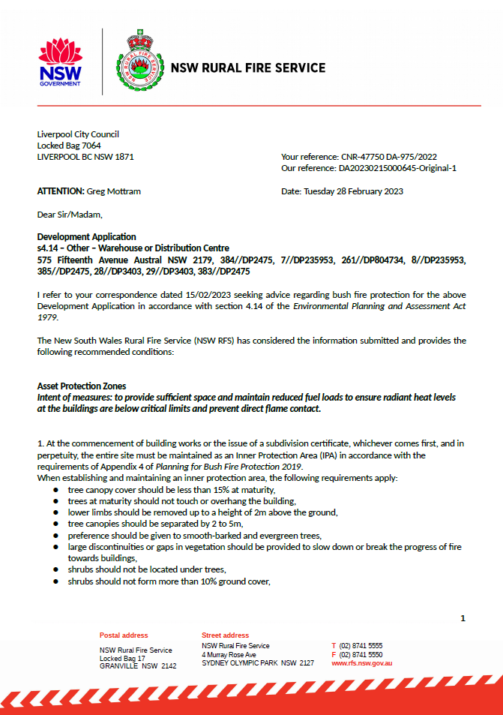

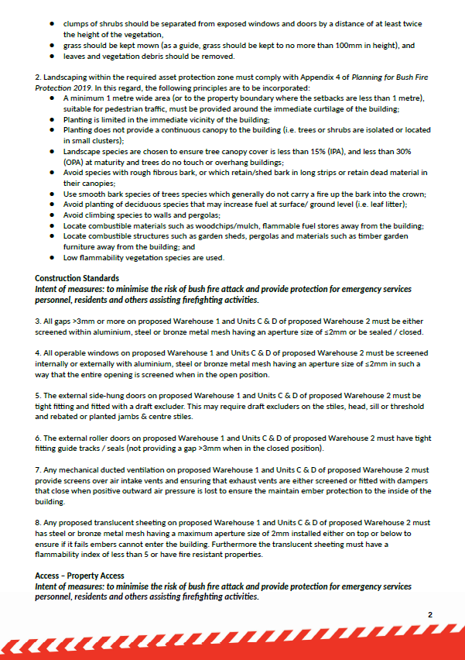

**ATTACHMENT 4 – Sydney Water Requirements**

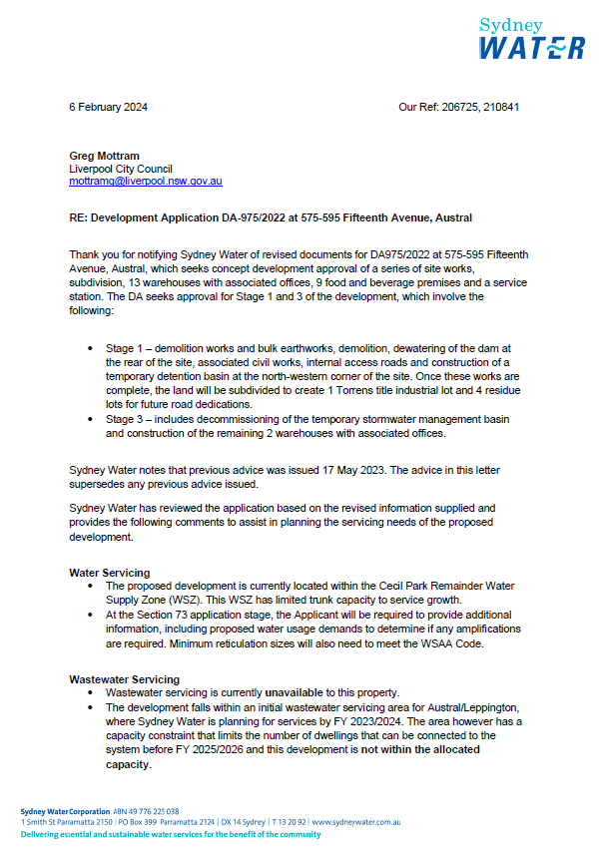

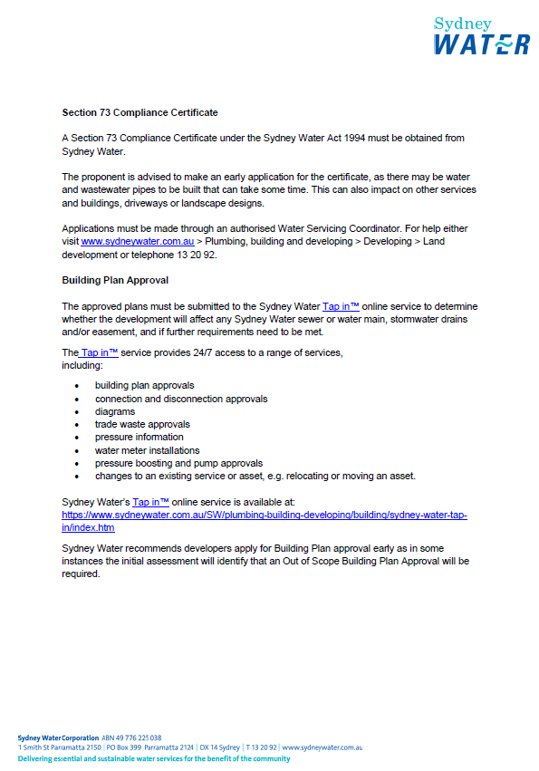

**ATTACHMENT 5 - Endeavour Energy Requirements**

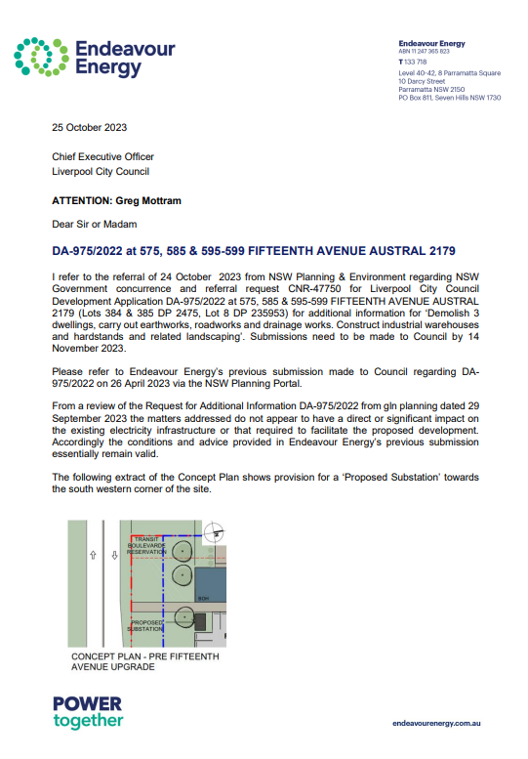

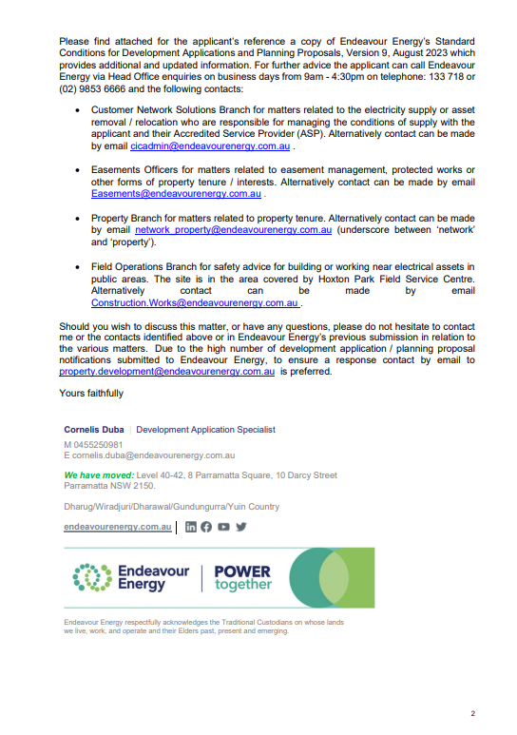

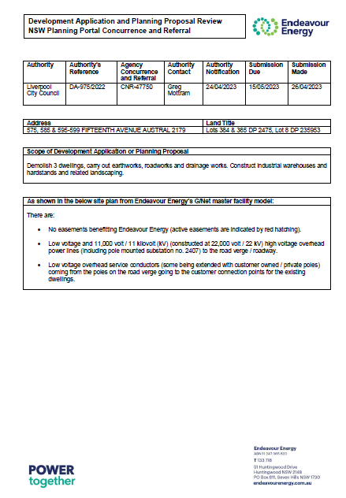

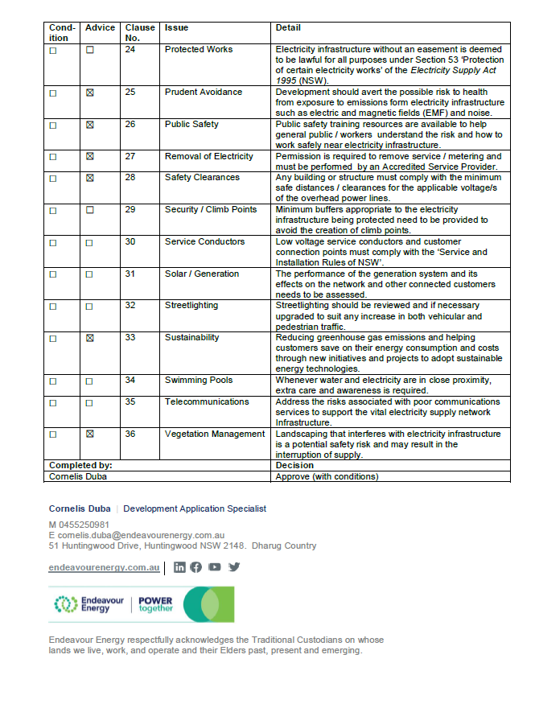

**ATTACHMENT 6 – Requirements of Transport for NSW**

